**Online Bird Rescue Platform**



**Under the supervision of**

[**Sumya Akter**](https://nub.ac.bd/pims/faculty-member/pi90ravw/sumya-akter)

**Lecturer**

**DEPARTMENT OF COMPUTER SCIENCE AND ENGINEERING**

**NOTHERN UNIVERSITY BANGLADESH**

**Submitted by**

**Mazharul Islam**

(ID: 04200101478)

**Md. Sazzad Hossen**

(ID: 04190101294)

**A Project Report Submitted in Partial Fulfillment of the Requirements for the Degree of Bachelor of Science in Computer Science & Engineering.**

**DEPARTMENT OF COMPUTER SCIENCE AND ENGINEERING**

**NOTHERN UNIVERSITY BANGLADESH**

**APPROVAL**

The Project Report “Online Bird Rescue Platform” submitted by Mazharul Islam (ID: 04200101478) and Md. Sazzad Hossen (ID: 04190101294) to the Department of Computer Science and Engineering, Northern University Bangladesh, has been accepted as satisfactory for the partial fulfillment of the requirements for the degree of Bachelor of Science in Computer Science and Engineering and approved as to its style and contents.

Board of Examiners

1. Sumya Akter (Supervisor)

Lecturer

2. Simon Bin Akter (Examiner)

Lecturer

3. Rumman Bin Prodhan (Examiner)

Lecturer

---------------------------------------

Md. Raihan Ul Masood

Associate Professor and Head

Department of Computer Science and Engineering

Northern University Bangladesh

**DECLARATION**

We, hereby, declare that the work presented in this Project report is the outcome of the investigation performed by us under the supervision of Sumya Akter, Lecturer, Department of Computer Science and Engineering, Northern University of Bangladesh. We also declare that no part of this Project has been or is being submitted elsewhere for the award of any degree or diploma.

**Signatures of Candidate**

.............................................

Mazharul Islam

(ID: 04200101478)

...............................................

Md. Sazzad Hossen

(ID: 04190101294)

**ABSTRACT**

The preservation of natural bird habitats is paramount to maintaining ecological balance and biodiversity in our world. Bangladesh, with its rich and diverse avian population, plays a crucial role in this global effort. However, the ever-increasing threats to these habitats and their resident bird species demand proactive measures for conservation and rescue. Avian species are an integral part of our ecological tapestry, enriching our environment with their songs, colors, and ecological functions. Bangladesh, as a habitat for countless bird species, stands to benefit significantly from promoting awareness of these winged wonders. Knowing how to identify, protect, and rescue these birds is an invaluable asset in our conservation efforts. An online platform entirely based on birds in Bangladesh is all about helping birds and educating people. A place where you can ask for help if you find a bird that needs rescuing. It can also have a lot of easy-to-understand information to teach people about different kinds of birds, where they live, and how our actions can affect them. Besides helping birds, a platform brings people together who love birds and want to help. It can let you report birds that need help, find groups that can rescue them, and share your own stories. By using the internet, an online platform makes it easy for people to work together and make sure birds in Bangladesh stay safe. Our development of such online platform and all its tools can be very feasible for rescuing birds which allows users or visitors to inform us about bird that need rescuing. We have a few animal rescuing organizations in Bangladesh, mostly in Dhaka such as PAW Foundation, Obhoyaronno, ARB etc. and they are doing noble works. Our easy to access online site can be very effective for such a rescue team and especially birds as the little feathered ones need rescuing way fast

**ACKNOWLEDGEMENTS**

We would like to thank certain people and all the blessing that helped us complete the project with such ease.

I would like to express my gratitude to all the dedicated educators at our university who have played a pivotal role in shaping my academic and personal growth. Each one of them has contributed to my journey, and I am deeply grateful for their guidance, knowledge, and unwavering support.

I extend my heartfelt appreciation to my supervisor, Sumya Akter, Lecturer, Dept. of Computer Science & Engineering, Northern University Bangladesh, whose guidance and support were instrumental in the successful completion of this project and preparing this book. Her unwavering dedication, insightful feedback, and wealth of knowledge have been invaluable throughout this journey.

Last of all, we are grateful to our family members. Their unflagging encouragement, love, and understanding have been our pillars of strength throughout this endeavor.

**Table of Contents**

|  |  |  |
| --- | --- | --- |
| **Chapter No.** | **Title** | **Page No.** |
|  | APPROVAL | i |
|  | DECLARATION | ii |
|  | ABSTRACT | iii |
|  | ACKNOWLEDGEMENT | iv |
| CHAPTER I | INTRODUCTION  1.1 Background  1.2 Problem Statement  1.3 Objectives  1.4 Limitations  1.5 Project Outline | 1  1  2  3  4 |
| CHAPTER II | LITERATURE REVIEW  2.1 Introduction  2.2 Related Works  REFERENCES | 4  4  5 |
| CHAPTER III | METHODOLOGY  3.1 Introduction  3.2 Problem Definition  3.3 Iterative and Incremental Development Model  3.4 Requirements  3.5 Design Development  3.5.1 Basic Modules  3.5.2 Design Overview  3.5.3 System Design  3.5.4 Data Flow Diagram (DFD)  3.6 Cost and Time Estimation | 6  6  7  9  10  10  10  12  17  21 |

|  |  |  |
| --- | --- | --- |
| CHAPTER IV | IMPLEMENTATION  4.1 Introduction  4.2 User Interface and Coding Details  4.2.1 Header and Navigation  4.2.2 Footer  4.2.3 Home page  4.2.4 Registration page  4.2.5 Login Page  4.2.6 User Dashboard  4.2.7 Bird Rescue Page  4.2.8 Donation Page  4.2.9 Other Pages  4.2.10 Administration Page  4.3 MVC  4.4 Database | 22  22  22  24  25  27  30  32  34  35  37  40  44  49 |
| CHAPTER V | RESULT AND DISCUSSION | 52 |
| CHAPTER VI | CONCLUSION AND FUTURE WORK  6.1 Conclusion  6.2 Future Work | 53  53  54 |
|  | REFERENCES  Appendix - Complex Engineering  Complex Engineering Problem (Ps): | 55  57-58  57 |

**CHAPTER I**

**INTRODUCTION**

**1.1 Background**

The Online Bird Rescue Platform is a web-based platform with a goal of keeping bird habitats in Bangladesh safe and helping their numbers to grow. Today the class Aves consists of approximately 9,000 species. In December 2019, [1] the International Union for Conservation of Nature (IUCN) listed 460 endangered avian species. [2] The avifauna of Bangladesh include a total of 827 species, of which fifty-one species are globally threatened. [3] Bangladesh has 25 Wildlife sanctuary [4] but a huge portion of avian species live outside of these and they are beyond help of any government organization when necessary. This platform aims to protect endangered bird species in the country and rescue birds in need. There are many people willing to participate in bird rescue program but they don’t know how to or who to knock for help. There were 66.94 million internet users in Bangladesh at the start of 2023, when internet penetration stood at 38.9 percent. [5] Participating in bird rescue by only using internet would be a breeze. A bird rescue platform is centered around birds but human resource is the fuel of it. Over 1 billion people volunteer at any field worldwide. [6] The number of people willing to volunteer will add more to that. Animal rescue operations needs volunteers regularly and a platform may help to find such kind hearted people. Wildlife rescue groups, unlike many other animal rescue organizations, focus on the rehabilitation of sick, injured and orphaned wild animals. [7] The platform can become an essential tool for other bird rescue organizations seeking to reach their goal by proactively rescuing birds and sending help as much as possible.

**1.2 Problem Statement**

Prior to the establishment of an Online Bird Rescue Platform, the process of reporting and rescuing injured or distressed birds faced significant logistical and communicative challenges. Sometimes, the lack of physical space become an obstacle to many good initiatives as bird rescue. Without having a physical space of their own, rescues depend on the generosity of their communities. [8] The existing methods relied heavily on scattered local initiatives and hotlines, often leading to delayed responses and inadequate coordination in handling bird rescue requests. The lack of a centralized and efficient system resulted in extended waiting times for

concerned individuals reporting injured birds, impacting the timely intervention needed for avian care and welfare.

Moreover, the absence of a streamlined reporting and tracking mechanism hindered the ability to provide timely updates to those reporting the distress, leading to uncertainty and a lack of transparency in the bird rescue process. This often left the public uninformed about the progress or resolution of reported cases, contributing to a loss of trust and satisfaction in the effectiveness of the rescue efforts.

Additionally, the fragmented nature of the existing reporting mechanisms posed challenges in compiling comprehensive data on the types, frequencies, and locations of bird distress incidents. The lack of such consolidated data made it difficult to identify patterns, trends, and critical areas requiring urgent attention for avian conservation and care.

Recognizing these challenges, the Online Bird Rescue Platform aims to revolutionize and address these inadequacies. This platform not only centralizes and streamlines the bird rescue process but also integrates a repository of resources and articles to educate and empower users about various avian species, their habits and ways to support their welfare. By providing a centralized, user-friendly and efficient system along with rich educational resources, the platform endeavors to enhance the response time, streamline rescue operations, offer real-time updates to reporters, compile crucial data for informed decision-making, and promote public awareness and understanding of avian conservation and care. Through the implementation of this integrated platform, it is anticipated that avian welfare and conservation will significantly benefit, and public satisfaction and trust in bird rescue initiatives will be substantially improved.

**1.3 Objectives**

The primary objective is to establish a comprehensive Online Bird Rescue Platform that efficiently conducts rescue operations. Having a website is essential for any animal rescue organization. It’s a great way to reach out to potential adopters and raise awareness about your cause. [9] Additional objectives offer educational resources and bird-sharing feature, while also facilitating access to the nearest veterinary care for pet owners.

Outlined outcomes include:

* Enhanced Avian Rescue Service: The Online Bird Rescue Platform aims to significantly improve the effectiveness and promptness of avian rescue operations. Users will experience streamlined and efficient reporting mechanisms for injured or distressed birds, enabling quicker response times and a more effective rescue process.
* Educational Resource Integration: A core component of this platform is the incorporation of a diverse array of resources and articles aimed at educating users about various bird species, their behaviors, and ways to support avian welfare. This feature aims to empower individuals with knowledge and understanding to better assist and contribute to avian conservation efforts.
* Updates and Transparency: By implementing a centralized reporting system, the platform seeks to provide updates to users reporting distressed birds, ensuring transparency and informed knowledge about the status of rescue efforts. This transparent approach aims to build trust and confidence in the efficacy of the rescue operations.
* Nearby Vet Access: To assist pet owners, the platform will integrate a feature to help locate and connect them with the nearest veterinary services. This functionality aims to ensure swift and appropriate medical attention for pet birds in distress, strengthening the overall support system for avian health and welfare.
* Efficient Resource Allocation: The platform aims to optimize resource allocation by leveraging data-driven insights garnered from the reported cases. Through the compilation and analysis of rescue data, patterns and trends in avian distress incidents can be identified, aiding in the efficient allocation of resources and proactive measures for avian welfare.

**1.4 Limitations**

* Geographic Coverage: The platform's effectiveness in connecting users with nearby veterinary services is limited by the geographic coverage of the database or service availability, which may not be comprehensive in all regions.
* User Adoption: The success and impact of the platform heavily rely on user adoption. Low user engagement or utilization could limit the efficacy of the platform's objectives.
* Resource Constraints: The thesis acknowledges that there may be resource limitations in terms of data collection, funding, or technical constraints that could affect the platform's ability to provide a comprehensive and continuously updated repository of educational resources and articles.

**1.5 Project Outline**

The report is organized into six chapters. After this introductory chapter, chapter 2 describes the survey of technologies. Chapter 3 describes the requirements analysis and methodology of the project. Chapter 4 describes implementation and testing process. Chapter 5 presents Result and discussion and finally Chapter 6, here we describe the conclusion and future work.

**CHAPTER II**

**LITERATURE REVIEW**

**2.1 Introduction**

The burgeoning interest in leveraging online platforms for avian rescue, education, and community-building reflects a dynamic shift in wildlife conservation efforts. This literature review delves into existing research on online platforms facilitating bird and animal rescue, emphasizing their dual role as educational tools and social community hubs.

**2.2 Related Works**

Numerous studies highlight the pivotal role of online platforms in wildlife rescue. Tomer Simon, Bruria Adini, Mohammed El-Hadid, Avishay Goldberg and Limor Aharonson-Daniel (2014) underscore the importance of these platforms in facilitating timely bird rescue operations, emphasizing the need for efficient communication and collaboration among stakeholders. [10] Additionally, International Bird Rescue (2023) provides valuable insights into global best practices, [11] offering a comprehensive perspective on the operational strategies and impact assessment of bird conservations.

The transformative potential of online platforms extends beyond immediate rescue efforts, fostering vibrant communities with a shared passion for wildlife conservation. Madelene Blaer (2021) discusses digital technology-enhanced approaches to support volunteers engagement, animal welfare and rights. His writings show that Animal Aid engages digital technology-enhanced approaches, especially information and communication technologies and social media, to heighten awareness and engagement in animal welfare and rights. [12] The impact of online platforms emphasizes how community engagement, facilitated through forums and shared experiences, contributes to a sense of collective responsibility and empowerment among users. Sutirtho Roy (2023) talked about the role of Social platform in Conservation. Social media has evolved with extremely contrasting aspects. It manages to connect people across the globe. Animal welfare is no different. [13]

Education and awareness play a key factor in reducing animals’ suffering. Suffering of avian or any animal species often caused by humans. As the platform’s one of the main goals is to give the avian species a good habitat, it is needed for people to get proper education about them. Sutirtho Roy (2023) also talks about how generating awareness also helps us respond to the plight of animals. [13] Edward N. Eadie (2011) has talked about how education is necessary for animal welfare. He provided educational contexts involved in reduction of animal suffering. [14] A bird rescue platform should implement such educational contents to spread awareness.

Effective web design is crucial for engaging users and ensuring a positive online experience. A visually appealing and well-organized layout creates a favorable first impression, guiding users through the site with intuitive navigation. Renee Garett, [Jason Chiu](https://pubmed.ncbi.nlm.nih.gov/?term=Chiu%20J%5BAuthor%5D), [Ly Zhang](https://pubmed.ncbi.nlm.nih.gov/?term=Zhang%20L%5BAuthor%5D), and [Sean D. Young](https://pubmed.ncbi.nlm.nih.gov/?term=Young%20SD%5BAuthor%5D) (2016) provided valuable knowledge on how proper design has become a critical element needed to engage website and mobile application users. [15]

In essence, the synthesis of bird and animal rescue with educational initiatives and community-building represents a paradigm shift in wildlife conservation. These platforms not only serve as crucial tools for immediate intervention but also as catalysts for knowledge dissemination, awareness, and social cohesion.

**CHAPTER III**

**METHODOLOGY**

**3.1 Introduction**

The methodology adopted for the development of the Online Bird Rescue Platform underscores the essence of systematically crafting a dynamic and user-centric website. In the realm of software development, a methodology serves as the guiding framework, orchestrating the various phases of the project life cycle. Methodologies are important for creating better software projects. It helps developers plan, produce, and test software. [16] By delineating clear goals for each stage, it offers a roadmap for successful project completion within defined timelines. The chosen methodology, in this instance, is integral to the realization of a website that seamlessly integrates bird rescue functionalities, educational resources, and a user-friendly donation system. Embracing an Agile methodology, known for its adaptability and iterative nature, aligns with the dynamic requirements inherent in avian welfare, ensuring the platform evolves to meet the diverse needs of both bird enthusiasts and those seeking. Here we discuss about Iterative and Incremental Development Model.

**3.2 Problem Definition**

The Online Bird Rescue Platform aims to address a critical gap in the avian welfare domain. With a focus on bird rescue, the website caters to the needs of both enthusiasts and individuals seeking assistance for injured or distressed birds. The project recognizes the absence of a centralized and accessible platform for reporting and coordinating bird rescues. Our challenge lies in the lack of an automatic system for identifying and responding to avian distress calls.

In the avian context, our project operates in a niche where no dedicated online platform currently exists for coordinated bird rescues. The absence of such a system impedes the swift and effective response required to safeguard the well-being of our feathered friends. The methodology employed for this project involves the utilization of PHP Laravel, a robust framework renowned for its versatility and efficiency in web development. [17] Embracing an Agile approach allows for continuous refinement and adaptation, ensuring that the Online Bird Rescue Platform evolves to meet the dynamic needs of both users and the avian community it serves.

**3.3 Iterative and Incremental Development Model**

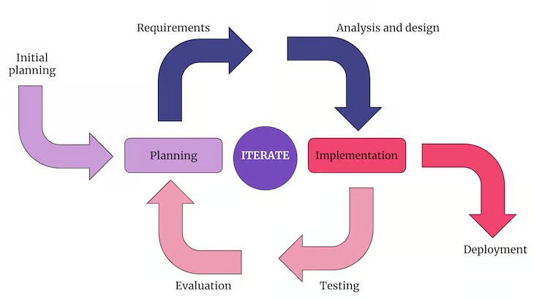

Fig 3.1: Iterative and Incremental Development Model

The Iterative and Incremental Development Model is an approach to software development where the project is divided into small parts or iterations, each of which goes through the entire development life cycle. It contrasts with the Waterfall Model by allowing for flexibility, adaptability, and the incorporation of feedback throughout the development process.

Key Characteristics of the Iterative and Incremental Development Model:

**Initial Planning:**

* The development process begins with initial planning, where the overall project goals and initial requirements are outlined.
* This phase involves setting the vision for the bird rescue website, identifying key functionalities, and planning for the iterative development approach.

The development process follows a recurring cycle, where each iteration goes through the following phases:

**Planning:** Each iteration starts with planning, refining goals based on feedback and adjusting the development roadmap.

**Requirements:** Specific requirements for the current iteration are identified, encompassing both bird rescue functionalities and educational components.

**Analysis and Design:** The team designs the features and structure for the identified requirements, considering user experience and ease of navigation.

**Implementation:** The actual coding and development of the website take place, incorporating the designed features and functionalities.

**Testing:** Rigorous testing is conducted to ensure the developed features work as intended and to identify any potential issues.

**Evaluation:** Stakeholders, including bird enthusiasts and potential donors, provide feedback on the implemented features, influencing adjustments for subsequent iterations.

**Deployment:**

* After several iterations, each refining and adding to the website's functionalities, the final deployment phase is reached.
* Continuous feedback and evaluation processes persist even after deployment, allowing for further improvements and updates based on user experiences and evolving needs.

In summary, the Iterative and Incremental Development Model, when applied to the bird rescue website project, follows a continuous cycle of planning, requirements analysis, design, implementation, testing, and evaluation. This iterative approach allows for the incorporation of feedback, adaptation to changing requirements, and continuous improvement throughout the development process, leading to a more responsive and user-centric website deployment.

Top of Form

**3.4 Requirements**

* Hardware: Computer
* Operating System: Windows
* Database : MySQL
* Programming Languages : HTML(5), CSS(W3), JavaScript(ES13), PHP(8.2), Bootstrap(5.3)
* Editor: Visual Studio Code
* Web Framework: Laravel
* Server: XAMPP

**MySQL/phpMyAdmin:** phpMyAdmin is a free software tool written in PHP, intended to handle the administration of MySQL over the Web. [18] It is one of the most popular database systems, known for its reliability, ease of use, and strong community support.

**HTML5:** HTML5, or HyperText Markup Language version 5, is the latest evolution of the standard markup language [19] used to create and structure content on the World Wide Web. It is a core technology in web development, alongside CSS (Cascading Style Sheets) and JavaScript. HTML5 was first released in a public-facing form on 22 January 2008 [20] with a major update and "W3C Recommendation" status in October 2014. [21]

**CSS:** CSS stands for Cascading Style Sheets. CSS describes how HTML elements are to be displayed on screen, paper, or in other media. CSS saves a lot of work. It can control the layout of multiple web pages all at once. [22]

**JavaScript:** JavaScript is a versatile programming language primarily used for creating dynamic and interactive content on the web. JavaScript was initially created to make web pages alive. [23] As a client-side scripting language, it runs in web browsers, allowing developers to enhance the functionality of websites and build responsive user interfaces.

**PHP:** PHP, which stands for Hypertext Preprocessor, is a server-side scripting language widely used for web development. PHP is embedded within HTML code and executed on the server, generating dynamic content that is then sent to the client's web browser. PHP could easily steal the Perl motto, "There's more than one way to do it," especially when it comes to file processing. [24]

**Bootstrap:** Bootstrap was created at Twitter in mid-2010. [25] It provides a set of pre-designed HTML, CSS, and JavaScript components, along with a responsive grid system, to streamline the development process.

**Laravel:** Laravel is a web application framework with expressive, elegant syntax. [26]It is a free, open-source PHP web application framework that follows the model-view-controller (MVC) architectural pattern. It is designed to make web development tasks, such as routing, caching, and authentication, easier for developers. [27]

**XAMPP:** XAMPP is a free and open-source cross-platform web server solution stack that includes the Apache HTTP Server, MySQL Database, PHP, and Perl. We will use Apache server and MySQL database from xampp.

**3.5 Design Development**

**3.5.1 Basic Modules**

Module refers to a discrete unit of functionality within a project. It is a way of organizing and structuring a software development project. Each module encapsulates related source files, build settings, and functionalities, allowing for modularity and maintainability in a project. Modules are designed to be independent units that can be developed, tested, and debugged separately, contributing to a more organized and scalable software architecture.

**3.5.2 Design Overview**

In the architectural design of the Bird Rescue Platform, the emphasis is on inclusivity, allowing users to access all functions, including bird rescue and donations, without the mandatory requirement of registration. The most important thing when creating an animal rescue website is to put the animals first. [9]

**Key Modules:**

* **Bird Rescue Module:** This module facilitates the reporting and coordination of bird rescue activities. Users, whether registered or not, can submit requests for bird rescues, ensuring that assistance is readily available to both the registered community and the wider audience.
* **Donation Module:** The donation functionality is intentionally designed to be accessible to all users, irrespective of their registration status. This inclusivity encourages a broad base of support for the avian welfare cause, allowing anyone to contribute to the platform's mission.
* **User Registration Module:** While user registration is an option, it is not mandatory for accessing core functionalities. The registration module primarily serves the purpose of creating an online community or society. Registered users gain access to additional features, such as personalized activity feeds, engagement metrics, and the ability to track and showcase their contributions to the bird rescue cause.
* **Login Module:** The login module allows registered users to securely access their personalized accounts and engage with the additional features offered through registration. Non-registered users can continue to access the platform's primary functions without any login requirements.
* **Handler Module:** The handler module is responsible for processing and managing specific types of events or requests within the system. It involves handling user inputs (feedbacks, rescue requests, live-chat etc.), managing data flow, or responding to specific triggers.

**Design Philosophy:**

The design philosophy of the Bird Rescue Platform centres around making bird rescue and support functionalities universally accessible. By not mandating user registration for core functionalities, the platform encourages a broader participation in avian welfare. The optional registration system serves as a mechanism to create an online society, fostering a sense of community and providing registered users with additional tools to track and celebrate their contributions to the platform's mission.

This inclusive design approach aims to maximize the reach and impact of the Bird Rescue Platform, ensuring that users of all backgrounds can actively participate in and support the welfare of our feathered friends.

**3.5.3 System Design**

System design involves the intricate planning and structuring of various components within a system, encompassing its architecture, modules, and elements. This process extends to defining interfaces between these components and managing the flow of data throughout the system. In essence, system design serves as the blueprint that guides the consistent and accurate realization of the envisioned system structure.

The web application framework we used in our project is Laravel which is a free, open-source PHP web application framework that follows the Model-View-Controller (MVC) architectural pattern.

**MVC Architecture**

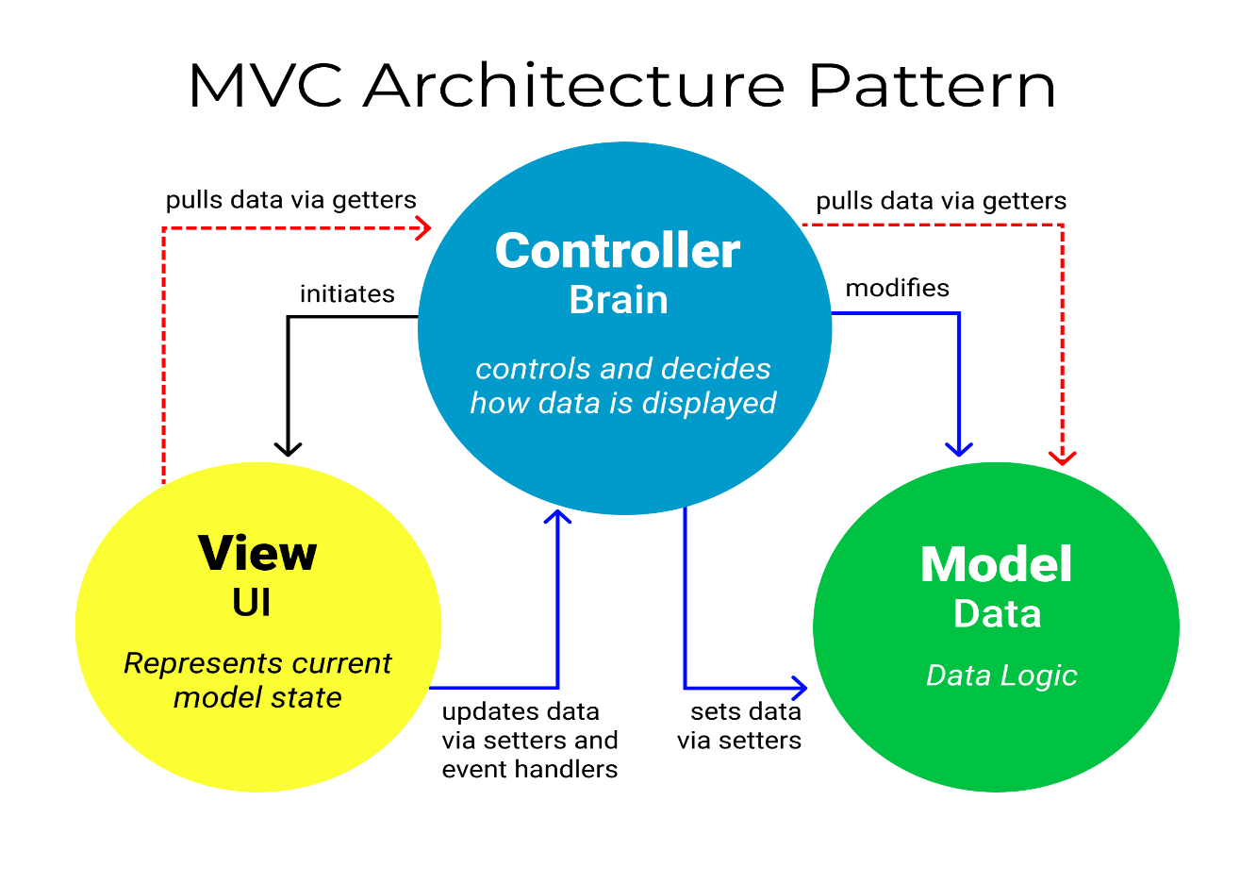The Model-View-Controller (MVC) architecture is a software design pattern that separates an application into three interconnected components: Model, View, and Controller. This separation helps in organizing code, improving maintainability, and promoting the reusability of components. MVC is one of the most frequently used industry-standard web development framework to create scalable and extensible projects. [28]

Fig 3.2: MVC Architecture Pattern

* **Model:** The Model represents the application's data and business logic. It is responsible for managing the application's state and behaviour. Data in the model can include information retrieved from a database, user input, or any other data source. Business logic, such as rules and algorithms, is implemented in the model to process and manipulate data. The model notifies registered observers (usually views) about changes in its state, allowing the views to update accordingly.
* **View:** The View is responsible for presenting the data from the model to the user and receiving user input. It displays the user interface elements and is concerned with the presentation and formatting of data. The View component is used for all the UI logic of the application. It generates a user interface for the user. [29] They observe the model for changes and update themselves accordingly. In web development, views are often associated with HTML templates, stylesheets, and client-side scripts.

**Each webpage is basically a View. Each page a user see after an http request is generated by a View.** In Laravel framework, Views combine blade files with script, stylesheets and other components. Blade files are built with PHP and HTML which mostly are the front-end codes. For coding efficiency and performance, we will arrange blade files in layouts that have **Header**, **Main** and **Footer** that attaches Header and Footer with Main page to generate a full page. Several pages were designed in order to meet the aims and objectives of the project. Such Pages are as follows:

1. User Login Page
2. User Registration Page
3. Administration page
4. Home Page
5. About Us
6. Birds Exploration
7. Articles Page

* Several Article Pages

1. Find Vets Page
2. Bird Images
3. News Page

* Several News Pages

1. Contact Page
2. Rescue Team Contact Page
3. Donation Page

**Blade:** Blade is the templating engine used in the Laravel PHP framework. Blade templates are key components in View that shows user interfaces and can combine them. Blade templates simplify the process of creating dynamic views in Laravel.

* **Controller:** The controller is the component that enables the interconnection between the views and the model so it acts as an intermediary. [29] It receives user input from the View, processes it, and updates the Model accordingly. Controllers contain the application's business logic for handling user actions, managing the flow of data, and updating the Model and View as needed. Controllers are often associated with server-side logic, handling HTTP requests, and managing the overall application flow.

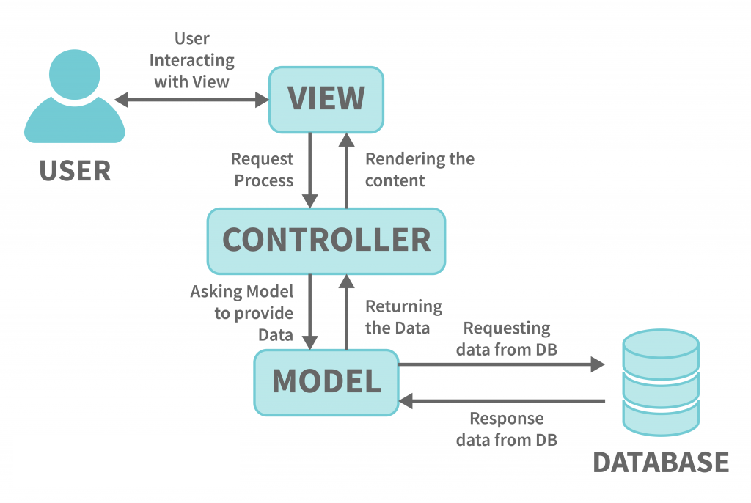

.

Fig 3.3: MVC Interaction Diagram

**Routing:** Laravel uses a powerful routing system to define the routes of an application. Routes determine how HTTP requests should be handled. They map URLs (URIs) to controllers or closures. Routes can respond to various HTTP methods (GET, POST, etc.) and can include parameters. One common way to handle the logic associated with a route is to use controllers. In the route definition, you specify which controller method should be executed when the route is accessed.

**User**

**HTTP**

**Request**

Route

**forward request to**

**appropriate controller**

**Read/Write**

**Data**

Database

**HTTP Response**

**(HTML)**

Model

Controller

**User**

Views

(Template)

A GET request using Route to the “/home” URL should trigger an anonymous function, returning the Home page. That means if the main domain is http://bdbirds.org, adding /home after that will generate Home page even though Home Page is the default page. Such routing terms are as follows:

/, /home Home Page /admin Administration Page

/about About Us Page /login User Login Page

/birds Birds Exploring Page /register User Registration Page

/vets Vets Information Page /donate Donation Page

/articles Article Page /rescue Contact for Rescue

/gallery Birds Images /contact Contact Us Page

/news News Page

Fig 3.4: MVC Routing and Interaction Diagram

**Middleware Components:** Middleware acts as a bridge between the incoming request and the application. It can modify the request, perform tasks, and even terminate the request before reaching the controller. Laravel comes with several built-in middleware for common tasks, such as handling sessions, verifying CSRF tokens, and authenticating users.

**Database:** A database is a structured collection of data organized in a way that makes it easy to manage, access, and update. Databases are a fundamental component in various applications, systems, and software, playing a crucial role in managing and organizing large volumes of data. Using a language such as PHP and a database such as MySQL allows us to make your sites dynamic: to have them be customizable and contain real-time information. [30]

* **Key components:**
* **Tables:** Data in a database is typically organized into tables, which resemble a spreadsheet with rows and columns. Each row represents a record, while each column represents a specific attribute or field.
* **Records:** A record is a complete set of information in a table, usually corresponding to a single entity or object. For example, in a database of users, each record might represent an individual user.
* **Fields:** Fields are individual pieces of data within a record, representing specific attributes. In an user database, fields might include Name, ID, email etc.
* **Queries:** Queries are used to retrieve specific data from a database based on defined criteria. They allow users to filter and extract information as needed.

**Environment:** In Laravel, the .env file is a configuration file used to manage environment-specific settings for the application. The .env file primarily contains key-value pairs that represent environment variables. These variables are used to configure various aspects of the Laravel application, such as database connections, application key, and more.

**3.5.4 Data Flow Diagram (DFD)**

In this segment, we will delve into the user-friendly features and intuitive design elements that enhance the overall browsing experience. By understanding the navigational structure and utilizing search functionalities, users can seamlessly explore the website. A Data Flow Diagram (DFD) is a graphical representation that illustrates the flow of data within a system and the processes that transform that data. It's a powerful tool for visualizing how data moves through a system, from input to processing and ultimately to output. DFDs are often used in system analysis and design to model the information flow and processes within a system. We will use this model to show user navigation and system automation for different tasks.

**User Registration:**

Stored User

Information

Fig 3.5: DF Diagram of User Registration

Valid

Invalid

Registered User

Registration Page

Home Page

/Default Page

User

**User Login:**

Stored User

Information

Fig 3.6: DF Diagram of User Login and Profile

Other Activities

Donations Record

Profile Information

Dashboard

Valid

Logged-in User

Invalid

Login Page

Home Page

/Default Page

User

**Bird Rescue Query:**

Home Page

/Default Page

User

Invalid Info

Fig 3.8: DF Diagram of Donation Process

Fig 3.7: DF Diagram of Bird Rescue Query

Valid

Payment Gateway

Billing Address

Form

Donate Page

User

Home Page

/Default Page

**Donation Process:**

**User Features:**

User

Home Page

/Default Page

Features

Feedback

Image Gallery

Share Birds

Bird Articles

Find Vets

Search Engine

Fig 3.9: DF Diagram of User Features

**Administration:**

Admin

Admin Page

Fig 3.10: DF Diagram of Administration

**3.6 Cost and Time Estimation**

Our initial setup will be done acquiring free available resources such as xampp with apache server and mysql database. Hardware is pre-owned. To test admin’s quicker response to any rescue query, we will implement LiveChat and purchase subscription for four months which will cost $20 per month. Hence, $80 in total or around 9000/- BDT based on USD to Taka conversion rate during that time. We will hire a couple of volunteers to test the site and its functions on different devices such as smartphone, low-end PC etc. which will cost 2000/- BDT for each and 4000/- BDT in total. So, the total cost of our system development and implementation will be around 9000 + 4000 = 13000/- BDT. Overview of time estimation for our proposed system is given in figure 3.11 below.

|  |  |  |  |  |  |
| --- | --- | --- | --- | --- | --- |
| **Attributes** | **March-**  **April**  **(2023)** | **May-**  **June**  **(2023)** | **July-**  **August**  **(2023)** | **September-**  **October**  **(2023)** | **November**  **(2023)-**  **January**  **(2024)** |
| **Literature**  **Review** |  |  |  |  |  |
| **Requirement**  **Analysis and Tool**  **Selection** |  |  |  |  |  |
| **Server**  **Environment Ready**  **And Deployment** |  |  |  |  |  |
| **Configuration and**  **Performance**  **Tuning** |  |  |  |  |  |
| **Report Writing** |  |  |  |  |  |

Fig 3.11: Overview of Time Estimation

**CHAPTER IV**

**IMPLEMENTATION**

* 1. **Introduction**

Implementation is the realization of an application or execution of a plan, idea, model, design, specification, standard, algorithm or policy. To implement a project means to carry out activities proposed in the application form with the aim to achieve project objectives and deliver results and outputs. In the context of web development, implementation refers to the stage in the development process where the planned design, features, and functionalities of a website are brought to life through actual coding and programming. This is when web developers write the necessary code, create web pages, and integrate various elements to realize the envisioned website. Implementation involves translating the design mockups and specifications into functional and interactive web pages. It encompasses tasks such as writing HTML, CSS, and JavaScript code, integrating databases, and ensuring that the website's features work as intended. The goal is to turn the conceptual aspects of the website into a fully functional and accessible web presence.

**4.2 User Interface and Coding Details**

**4.2.1 Header and Navigation Menu**

Header and Navigation menu is a common section for all pages. It consists of Logo, Name, Links or menus that direct users to different sections or pages of the website.



Fig 4.1: Common Header and Navigation Menu

* The navigation menu contains links to various sections of the website, including "Home," "About," "Explore Birds," and a dropdown for additional features.
* The "Features" dropdown includes links to finding vets, articles, bird images, news, sharing bird images, and sending feedback.
* The "Contact" dropdown provides links to contacting the website, a hotline number, and contacting the rescue team.
* There is a link for donation that directs to donation page.

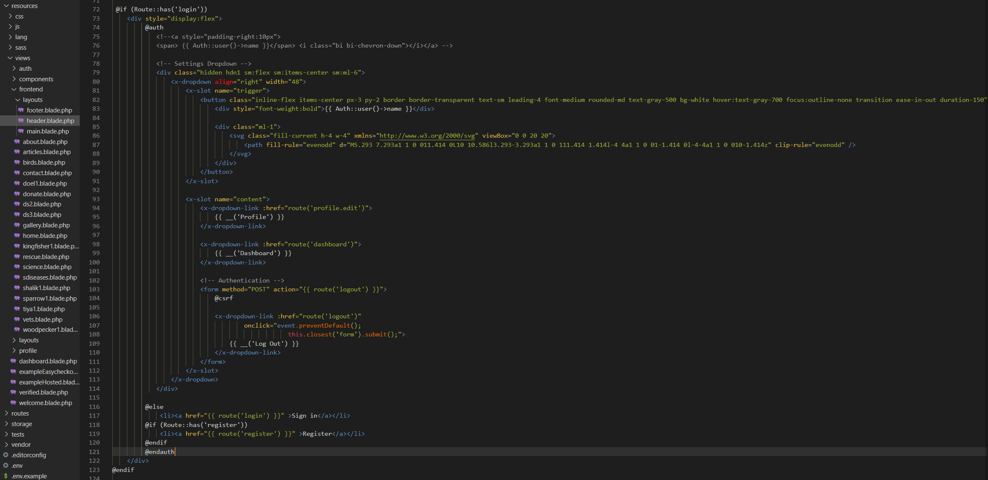

Fig 4.2: Code for Header and Navigation Menu

We implemented a dynamic header section that adjusts based on the user's authentication status. If the user is authenticated, a settings dropdown displays options like 'Profile,' 'Dashboard,' and 'Log Out.' If not authenticated, the header provides 'Sign in' and 'Register' links. This implementation enhances user experience by presenting relevant navigation options based on their authentication state.

**4.2.2 Footer**

* The bottom section of the page containing additional links, contact information, and social media links.

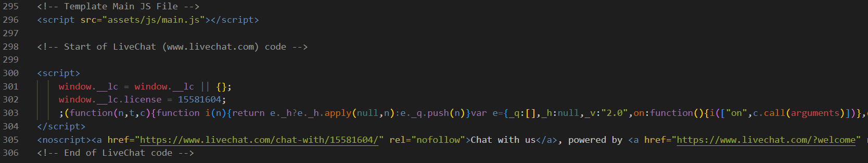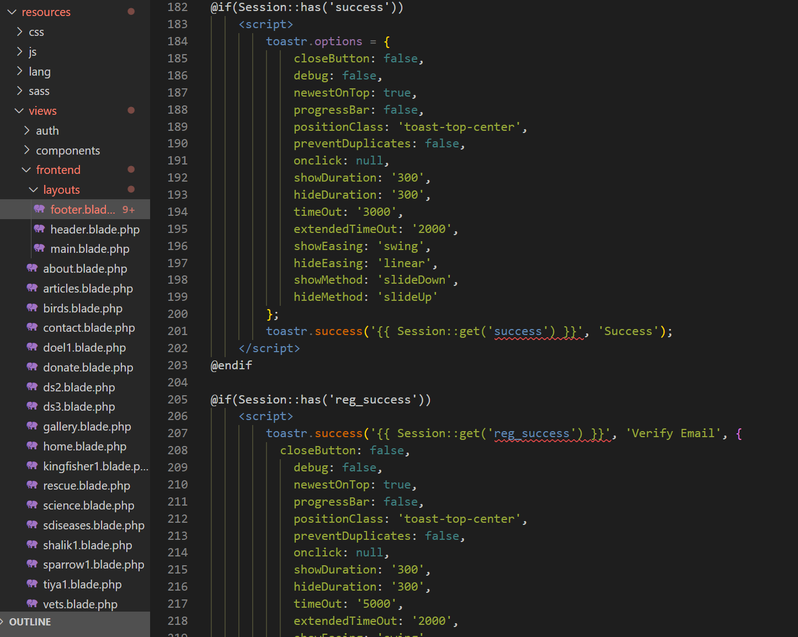

Fig 4.5: Code of Script for LiveChat

Fig 4.4: Code of Script for Alert

Additional scripts to show status for user login, registration, donation etc. are included in footer. Scripts that don’t have separate files are included in coding of footer. These could be implemented anywhere at any page without any changing effect but header or footer is suitable option as they dynamically tagged with all other pages.

Fig 4.3: Common Footer

**4.2.3 Home Page**

The home page of the website is the primary or main page that users will encounter when they visit the site's domain. It is the entry point and often considered the "front door" of the website. The home page serves as a central hub that provides users with an overview of the site's content, navigation options, and key features. Here are some common elements found on the home page:

* **Hero:** The page containing a full-screen bird image with animation triggered by mouse movement and a tagline.

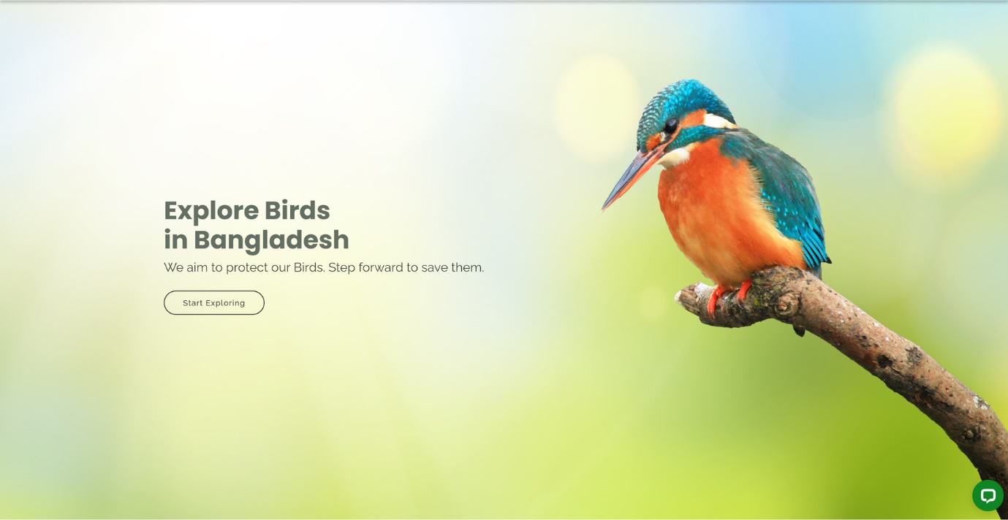

Fig 4.6: Home Page Hero

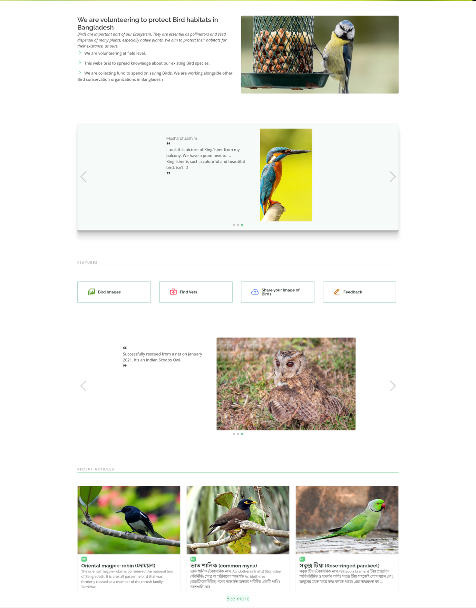**Featured Content:** Prominent or highlighted including articles, vets information, featured bird image, Gallery etc.

Fig 4.7: Home Page Featured Content

* **Call-to-Action (CTA):** Encourages users to take a specific action, such as signing up, exploring featured content, or making a donation.



Fig 4.8: Home Page Call-to-Action

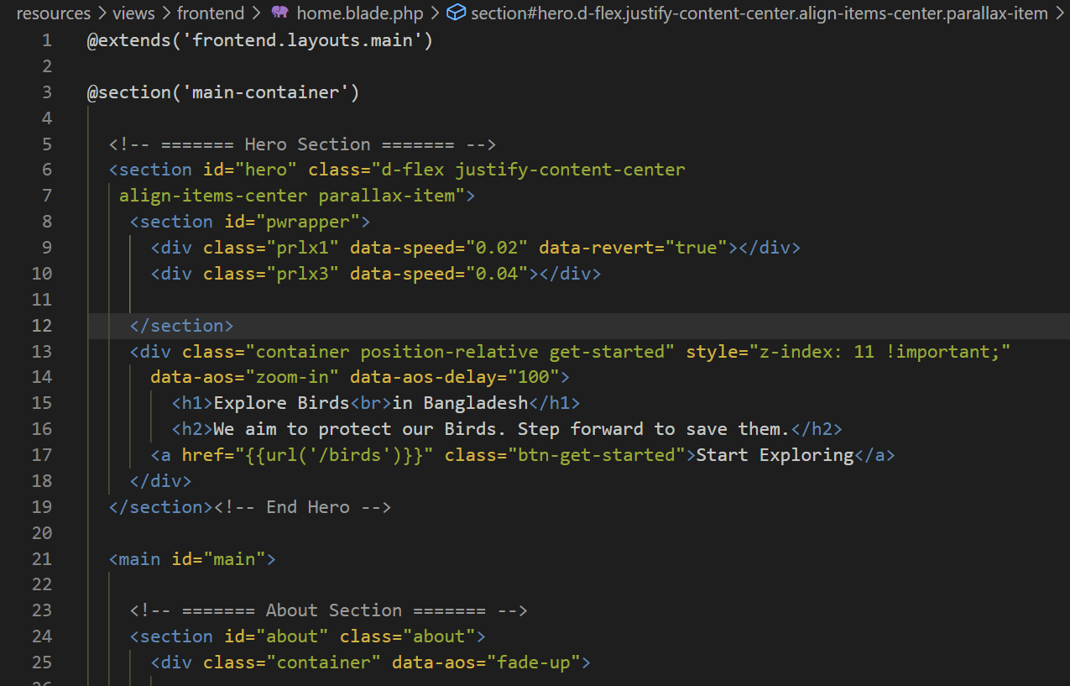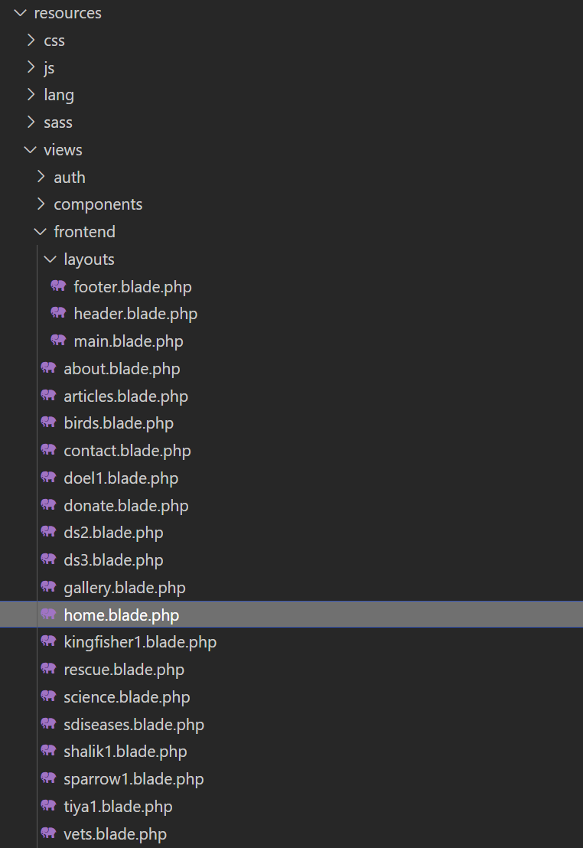

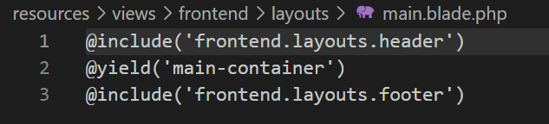

Fig 4.9: Code of Home Blade Template

Every Blade or View or Page except header and footer starts with addressing itself as main page which is the middle section of every page dynamically generated by Layout function tagging header and footer at the top and bottom respectively.

The View receives data from the Model and presents it in a format suitable for the user. This can include rendering HTML, displaying images, or presenting any other type of content.

1. We employ a structured approach to manage resources and streamline the creation of user interfaces. Within the "Resources" directory, we encapsulate essential components such as CSS, JavaScript, and Views.
2. One of the central pieces is the Blade templating engine, used to craft dynamic and reusable views. These Blade files, residing in the "Views" directory, amalgamate HTML and PHP code to define the user interface of various pages.
3. To enhance code organization and promote reusability, we implement a master Blade file. This file serves as a template that encapsulates the common structure shared across multiple pages, typically containing the header and footer components.

**4.2.4 User Registration Page**

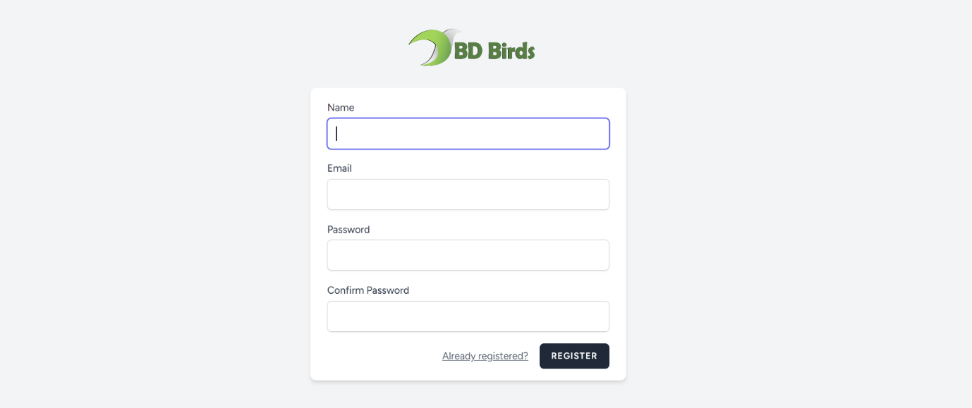

Fig 4.10: User Registration Form

**Registration View:** This registration view is the HTML template that users see when accessing the registration page. It includes form elements for users to input information such as name, email, password, and password confirmation.

**Registration Controller:** User Registration controller responsible for handling registration-related logic. This controller validates user input, creates a new user record in the database, and triggers events associated with user registration.

**Validation:** It incorporates form validation to ensure that users provide valid and secure information during registration. If there are validation errors, users will receive feedback and be prompted to correct their entries.

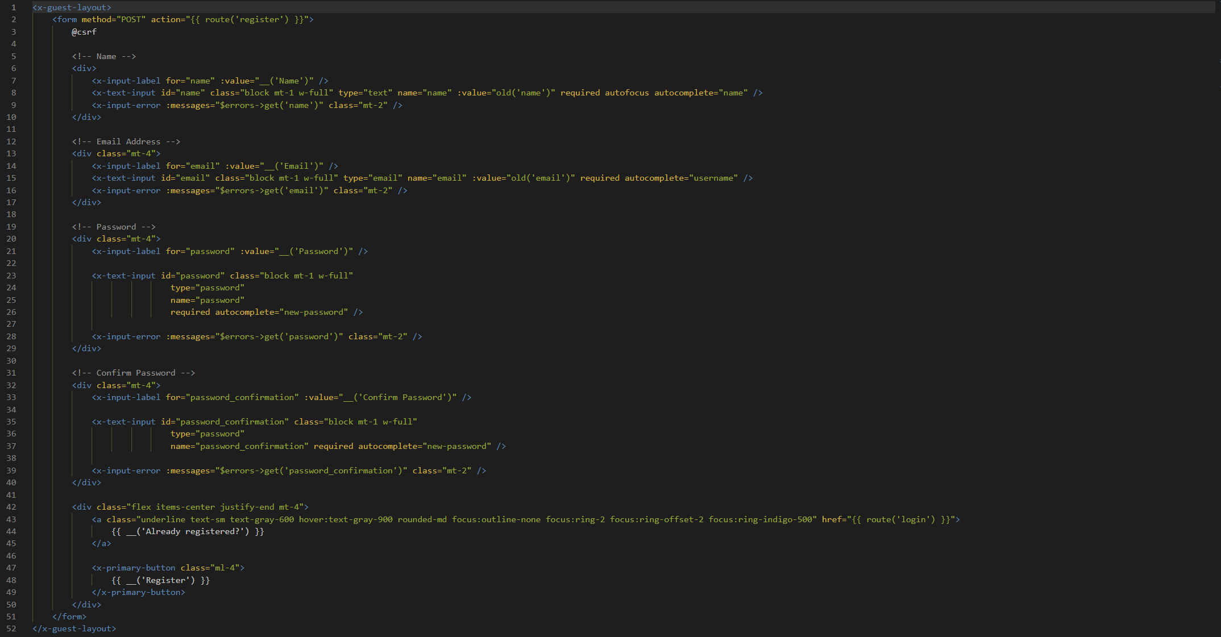**Email Verification:** It is configured to include email verification for new registrations. This feature sends a verification email to the user, and they need to confirm their email address before gaining full access to the application.

Fig 4.11: Code of User Registration Form

This code is for a user registration form within a guest layout. It includes fields for the user's name, email, password, and password confirmation. The form submits data to the 'register' route, and there are error message displays for validation issues. Users are provided with a link to the login page if they are already registered.

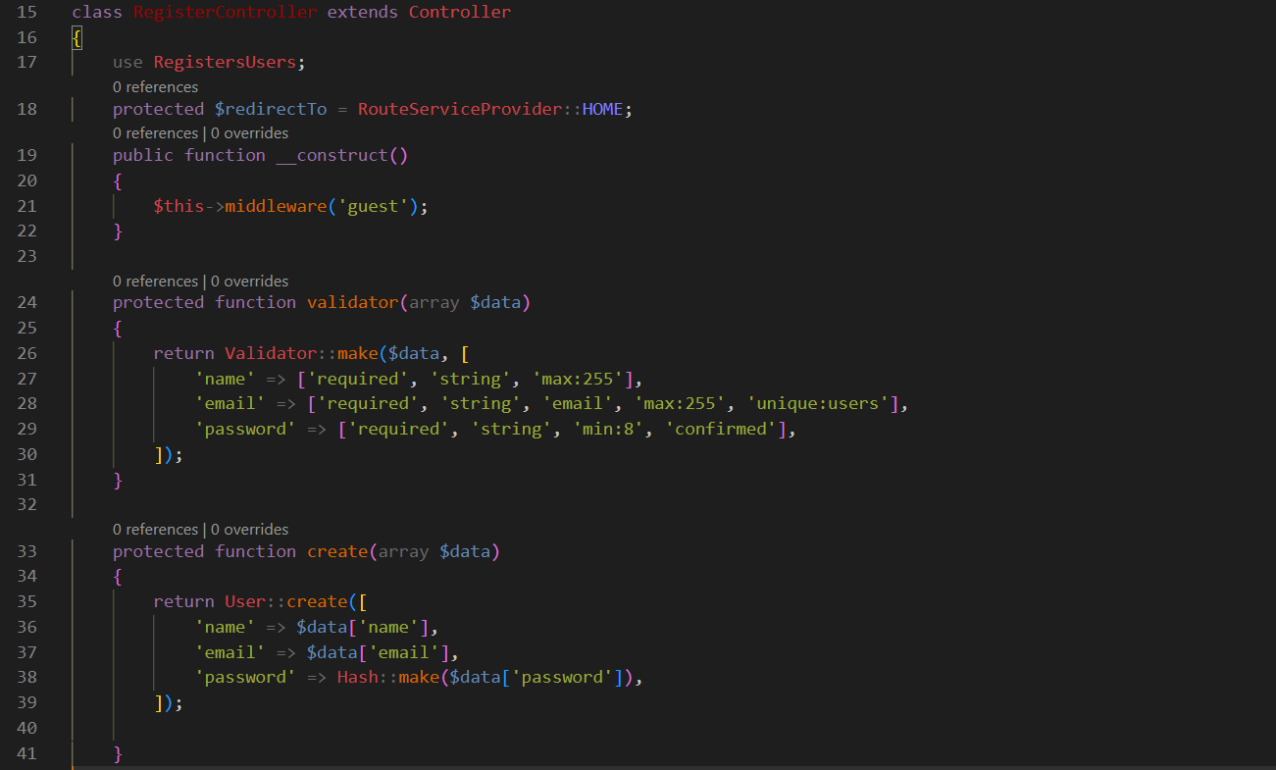

Fig 4.12: Code of User Registration Controller

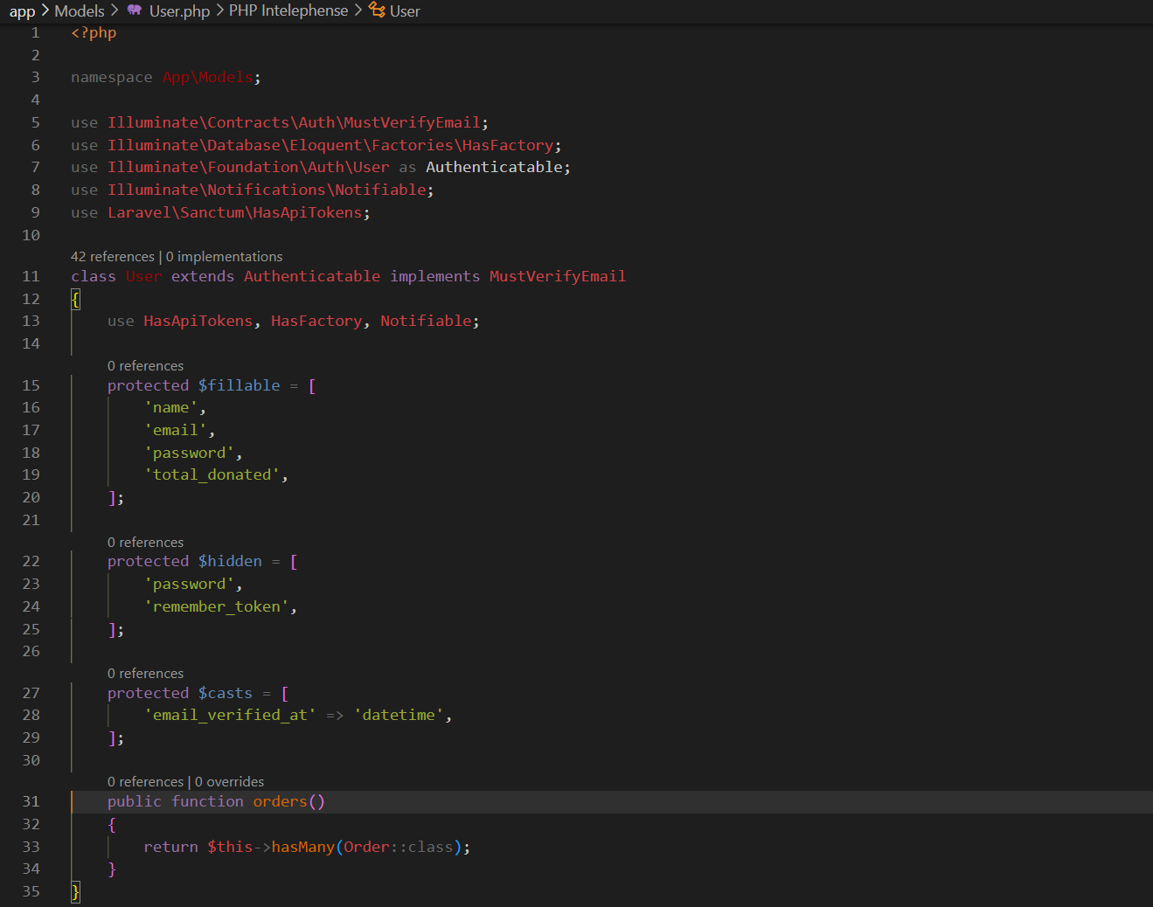

This user registration controller takes these users information and send to user database model and then model send it to database for storing.

Fig 4.13: Code of User Model

**4.2.5 User Login and Profile Page**

Fig 4.14: User Login Form

Registered users will be prompted to use their email and password to sign in. They will have option to reset their password. A password reset code will be sent to their email upon click on ‘forget your password?’. User Login Controller will verify correct inputs from database and will send User to home screen from where they can visit their profile. They will be able to change their profile Information and go to the dashboard to see their activity records on the platform including their detailed donation records if there any.

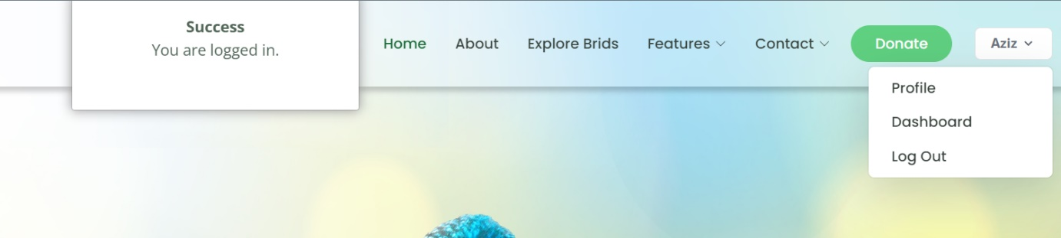

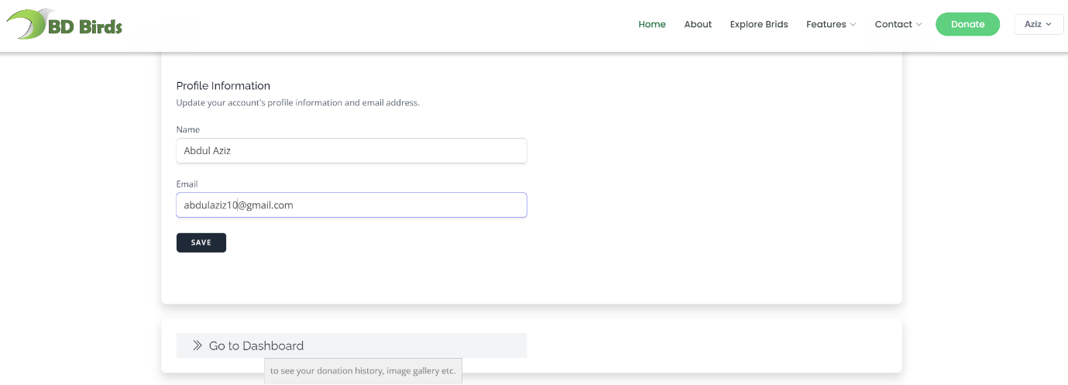

Fig 4.15: User Profile

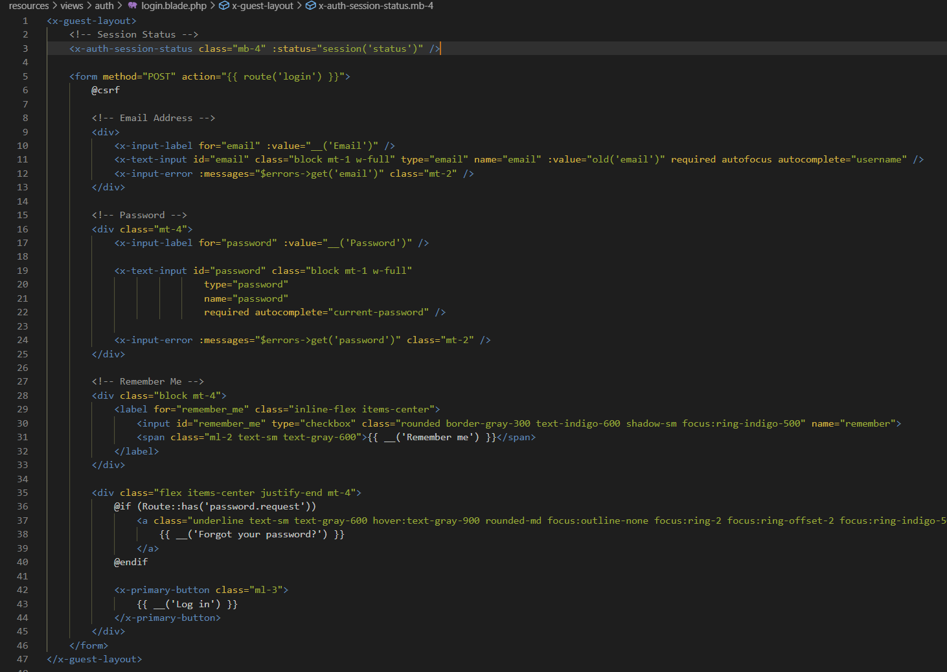

This code is for login form within a guest layout. It includes fields for the user's email and password, a "Remember Me" checkbox, and a link to reset the password.

Fig 4.16: Code of User Login Form

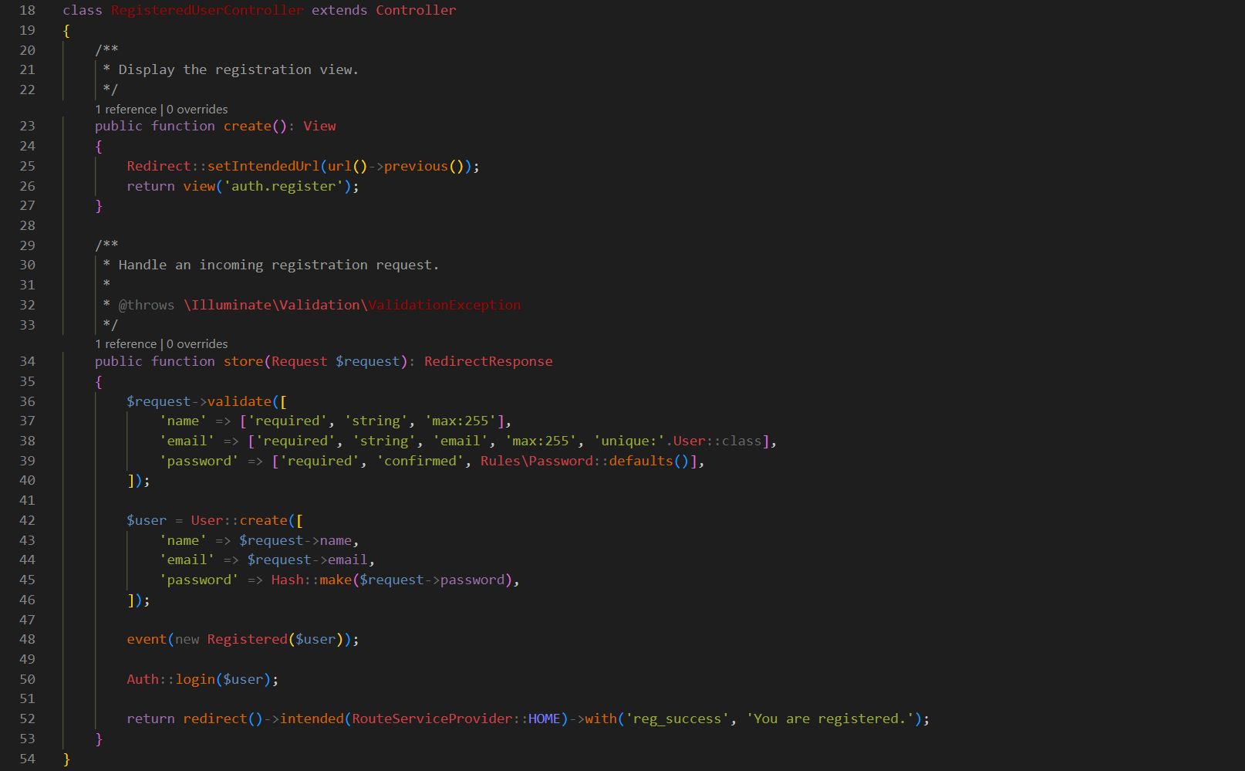

Fig 4.17: Code of User Login Controller

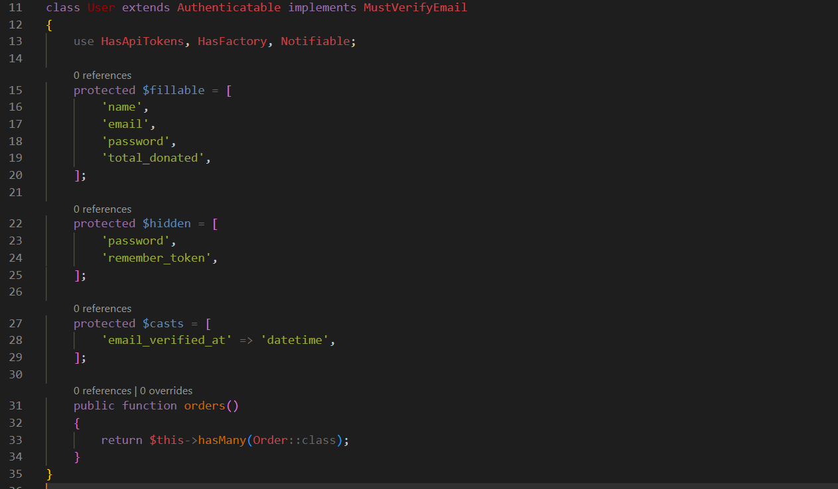Then it again gets sent to user model to check the information from database for checking.

Fig 4.18: Code of User Model

**4.2.6 User Dashboard**

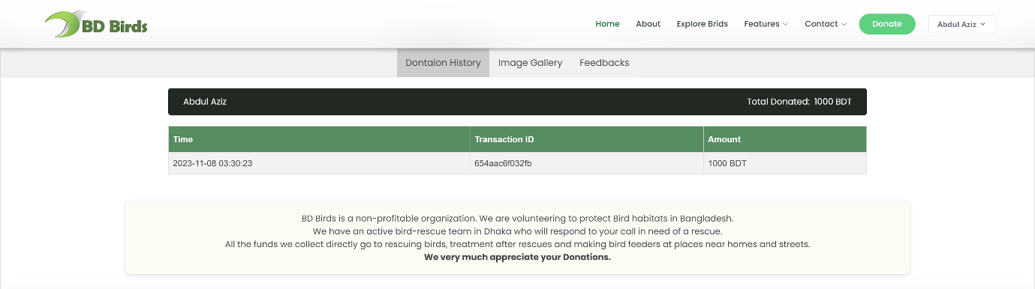

Fig 4.19: User Dashboard Template

This piece of code below for dashboard template displays the user's total donated amount, donation history, and a badge if they have the highest donation. If the user hasn't donated, it shows a message. The Information was retrieved from database.

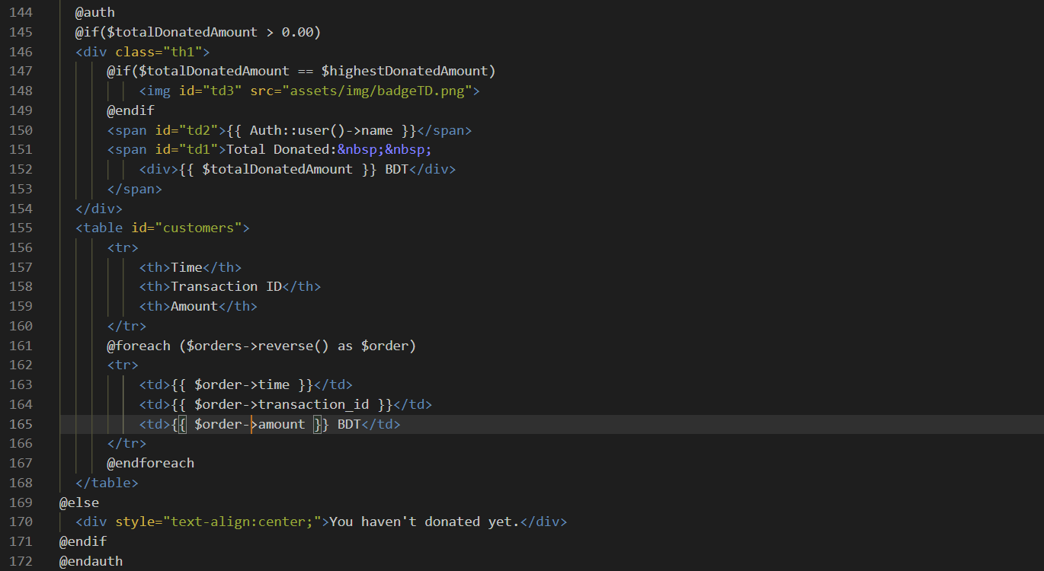

Fig 4.20: Code of User Dashboard

A dedicated user dashboard controller stores these user records with the help of a model.

Then again controller shows this information to user retrieving from database.

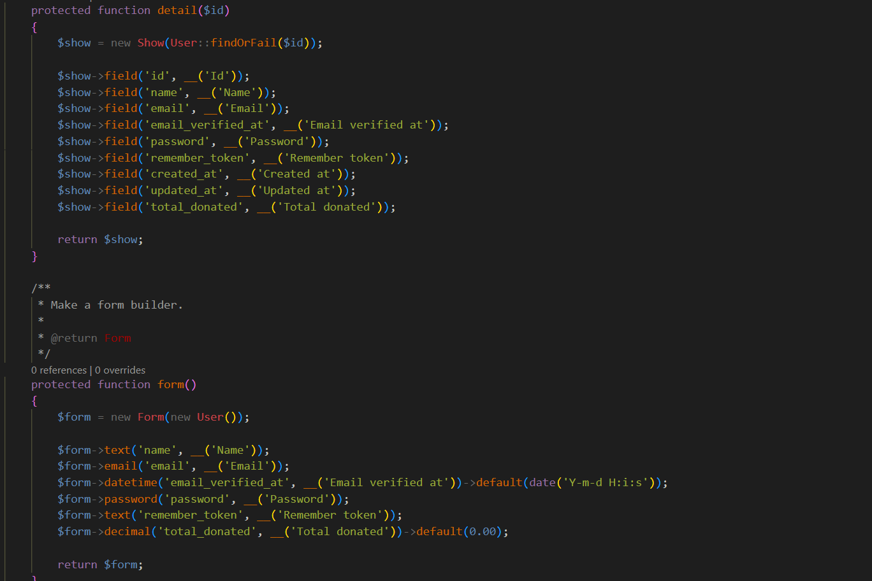

Fig 4.20: Code of User Dashboard Controller

**4.2.7 Bird Rescue Page**

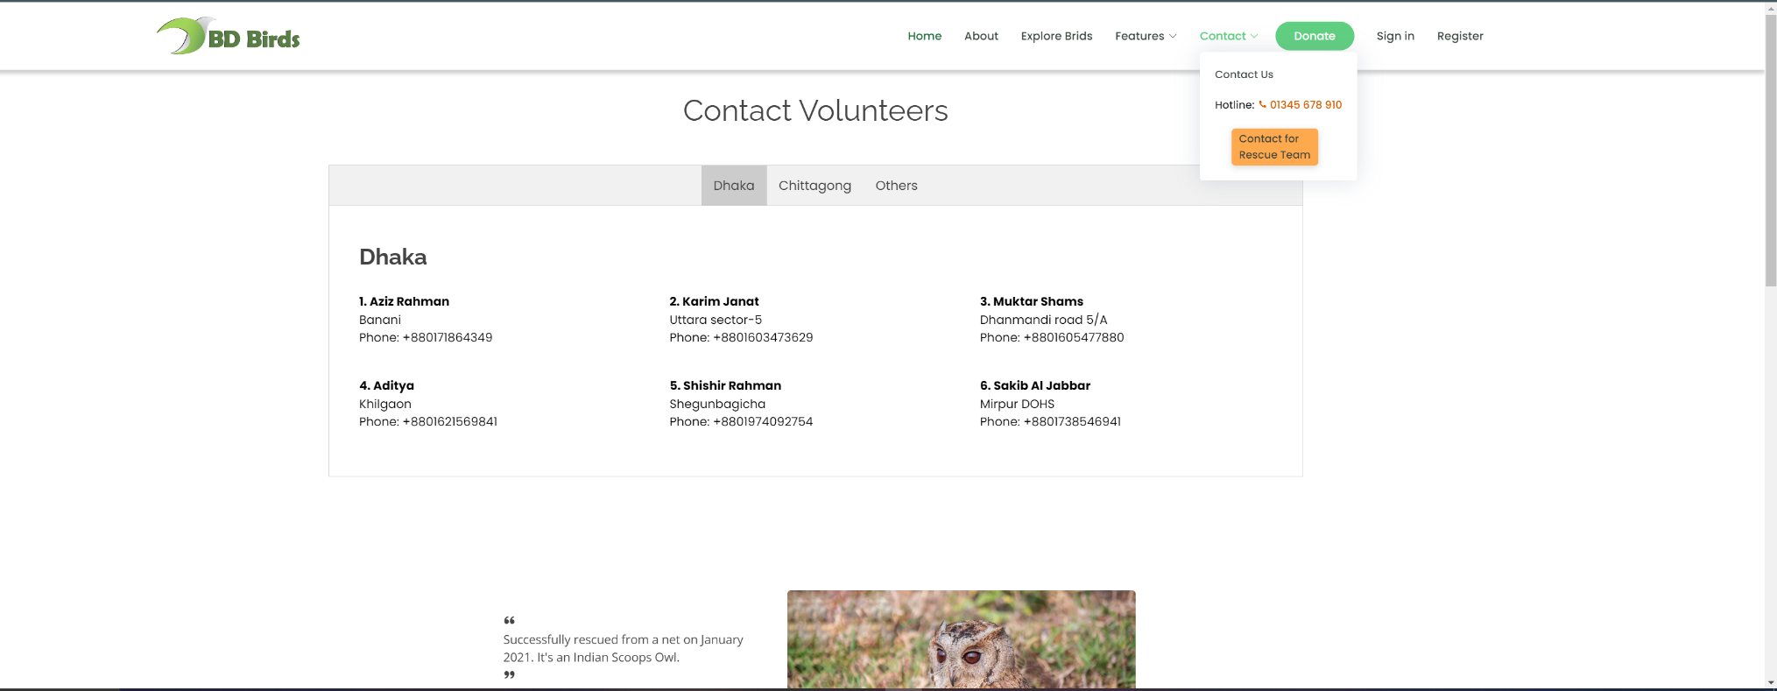

Fig 4.21: Bird Rescue Page

A prominent button labeled "Contact for Rescue Team" is accessible in navigation panel on every page of the website. Clicking on this button directs users to the Bird Rescue page.

Bird Rescue Page:

* Users can navigate to a specific "Bird Rescue" page from the "Contact for Rescue Team" section.
* On this page, users can find information about volunteers from different regions of the country who are part of the rescue team.

Live Chat and Hotline:

* Users can send bird rescue queries via live chat accessible from any page.
* A hotline is available for users who prefer or need immediate assistance.

This approach ensures multiple channels for users to seek assistance, whether it's through immediate live chat, a dedicated hotline, or a more detailed form on the "Contact for Rescue Team" page.

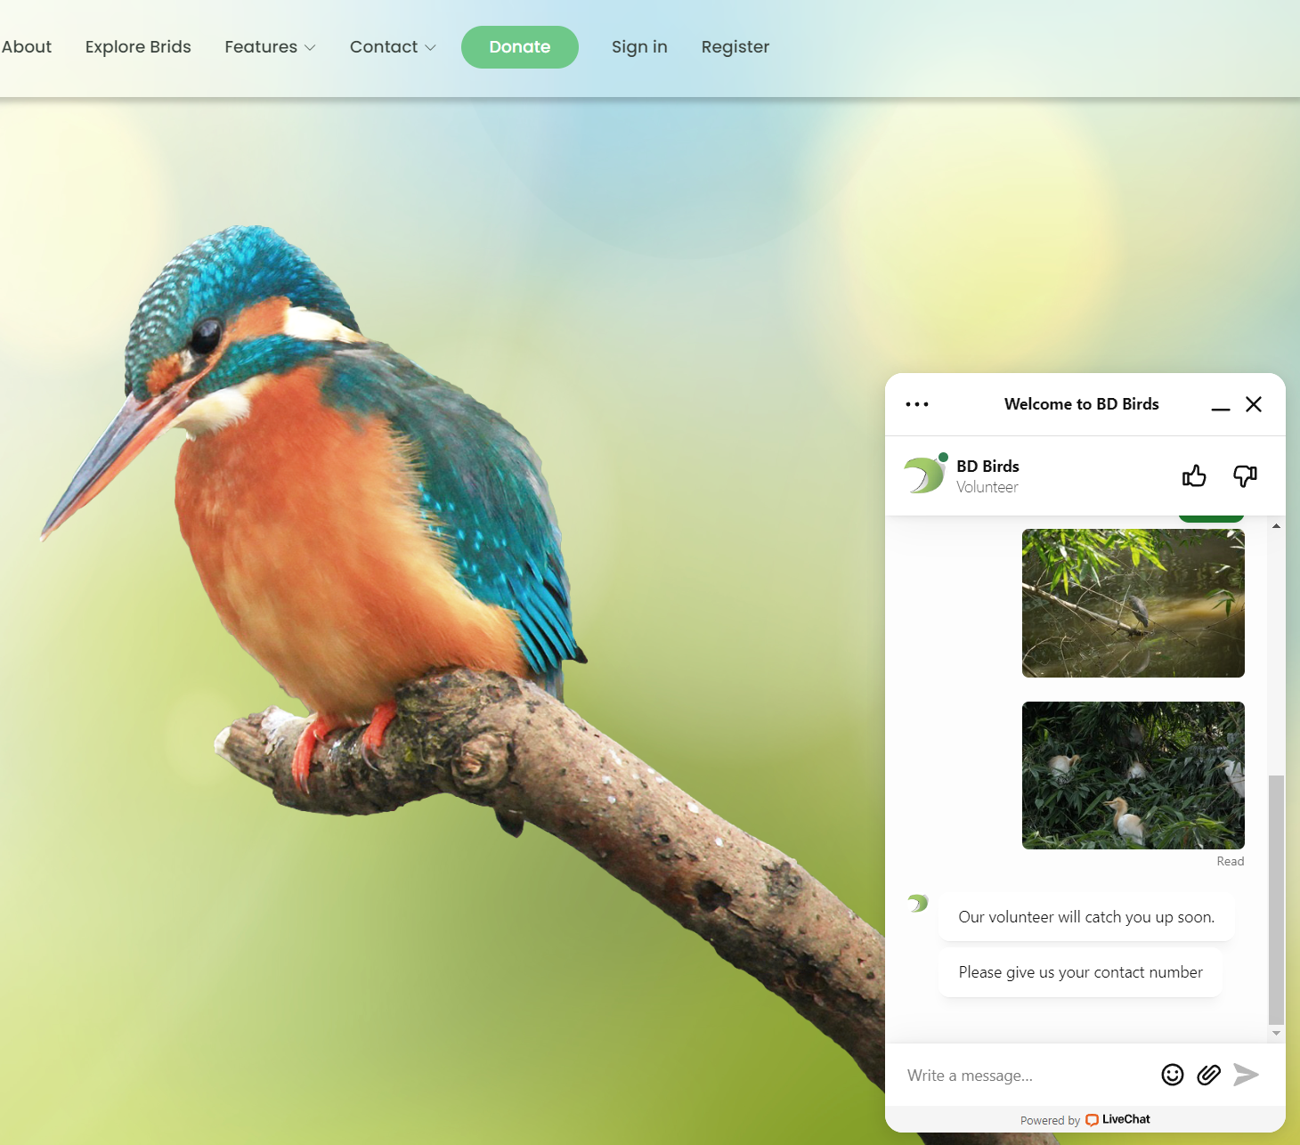

Fig 4.22: Live Chat Feature

**4.2.8 Donation Page**

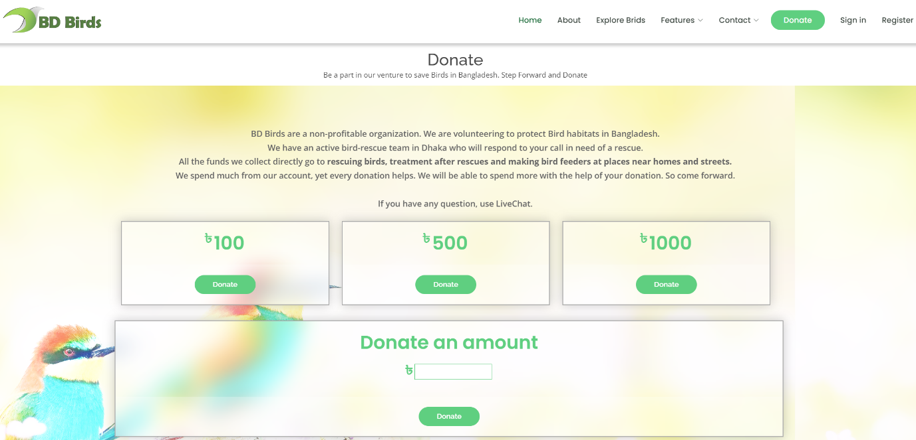

Fig 4.23: Donation Page

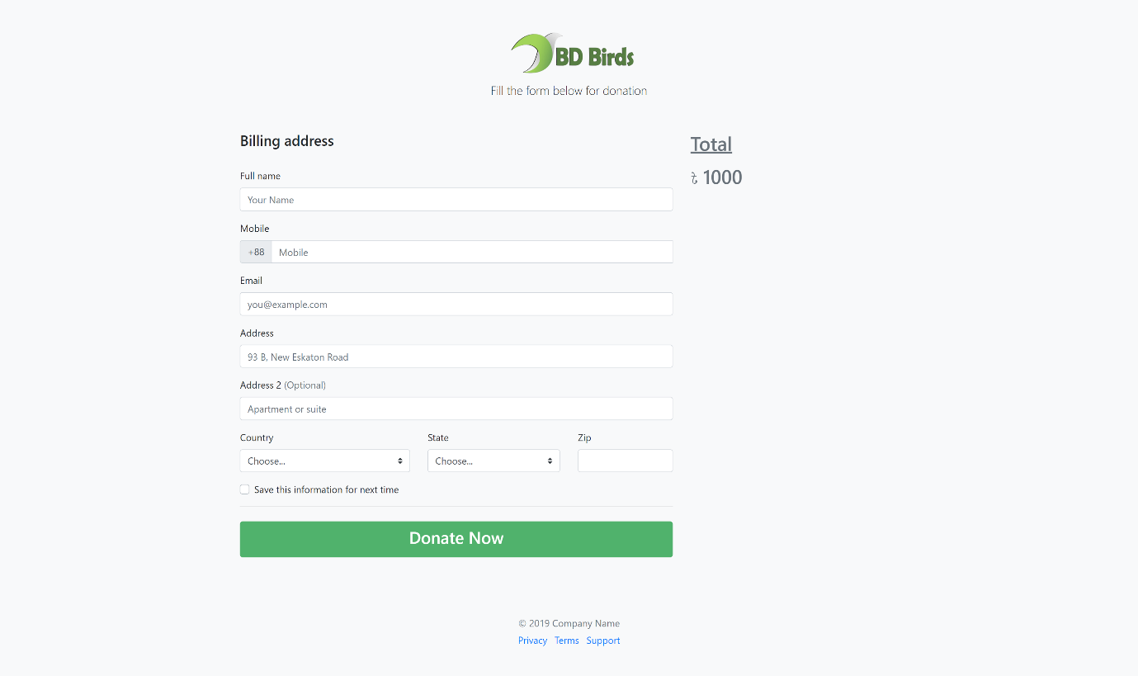User can donate to Organization using this page accessible through navigation menu on every page and CTA. After entering valid amount, user will be prompted to sign in as optional. There will a be billing address form to fill before payment.

User has to fill this form with correct information otherwise Handler will show warning asking user to input correct billing information including phone number, email.

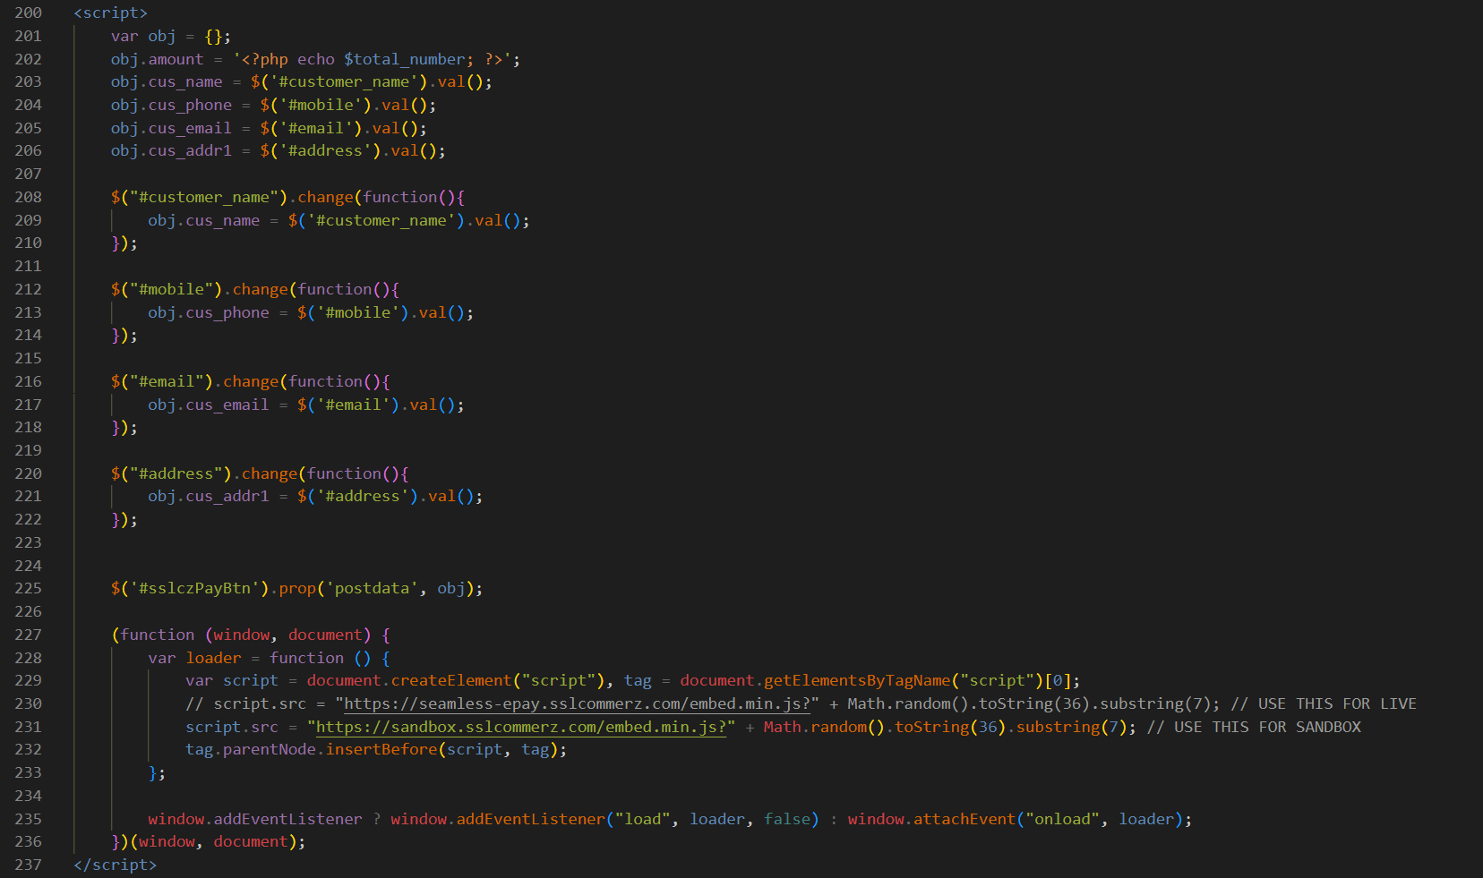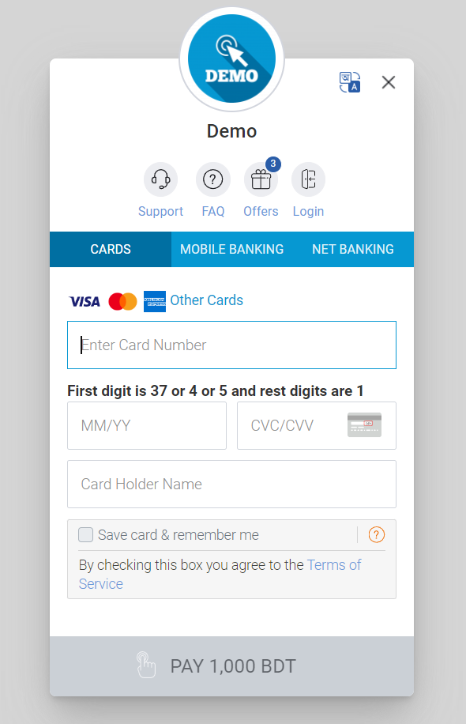

Fig 4.26: Code of Script for Donation Form

Fig 4.24: Billing Address Form

Fig 4.25: SSLCOMMERZ Gateway

After entering write billing address, ‘Donate Now’ button will take user to Payment Gateway. We used SSLCOMMERZ Gateway in this project.

This script above in donate page set up an object with various properties such as amount, customer name, phone, email, and address. It captures changes in the corresponding input fields and updates the object accordingly. Additionally, the script dynamically loads an external script from either the live or sandbox version of the SSLCommerz API.

**4.2.9 Other Pages**

**Find Vets Page**

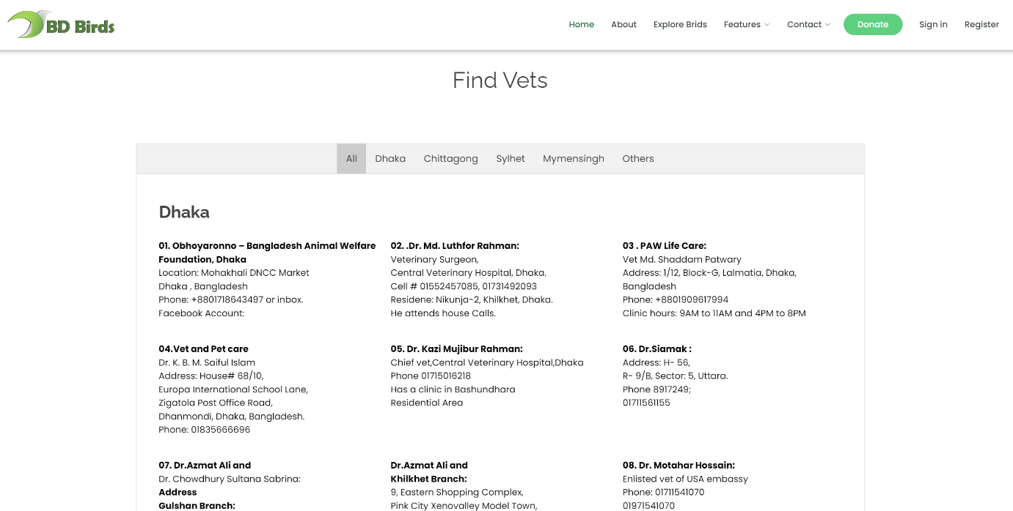

Fig 4.27: Find Vets Page

‘Find Vets’ page stands as a valuable resource for users seeking veterinary assistance. Tailored to serve both urban and regional needs, this page offers a user-friendly interface to discover vet information across various areas in Dhaka and different regions throughout the country.

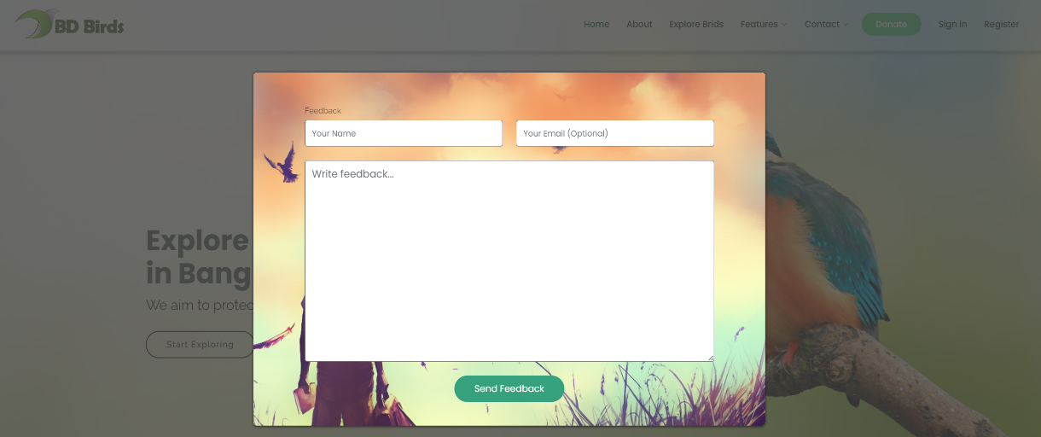**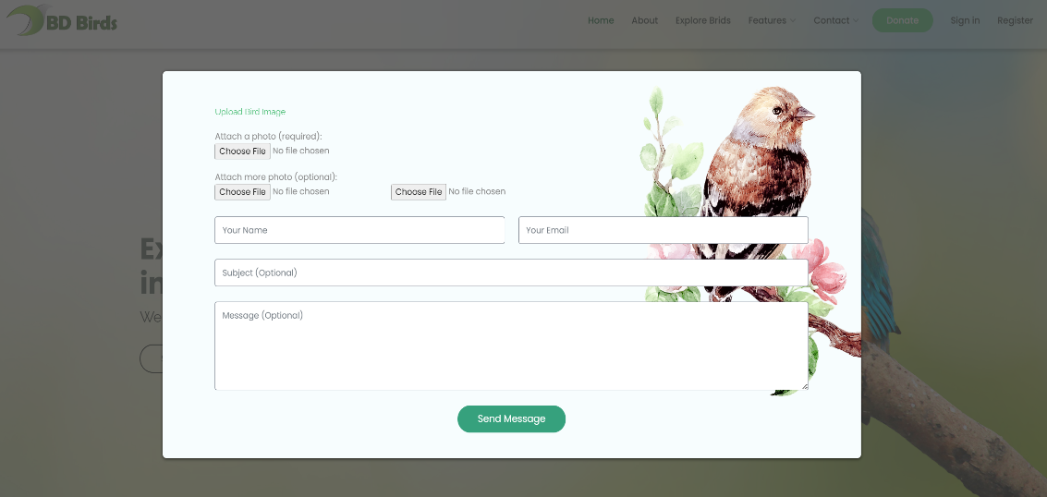Share Image and Feedback Form**

Fig 4.28: Share Image and Feedback Form

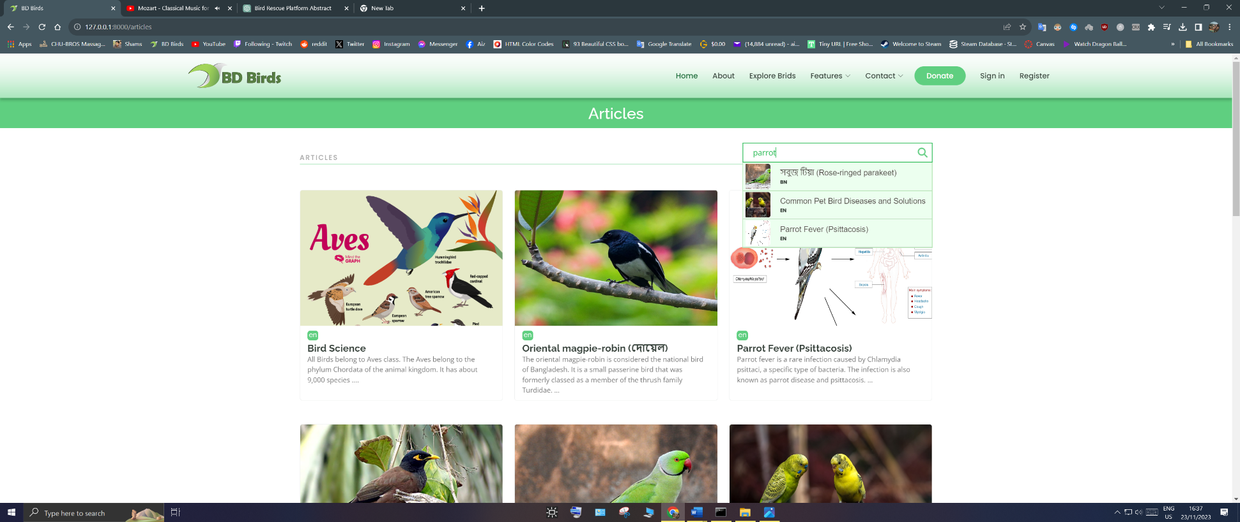**Articles and Educational Page**

Fig 4.29: Articles Page

Search Engine

The Educational hub, Articles Page, serves as a good resource for bird enthusiasts seeking knowledge on birds and their many diseases. To enhance user experience, we've integrated a robust search engine, empowering visitors to efficiently explore our extensive database.

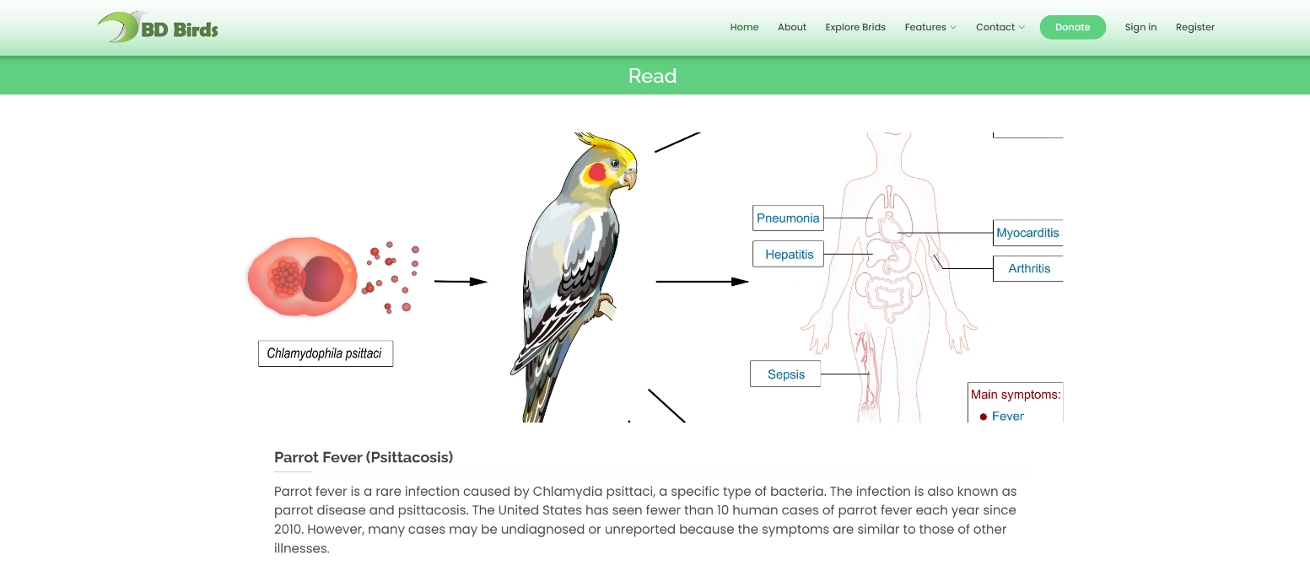

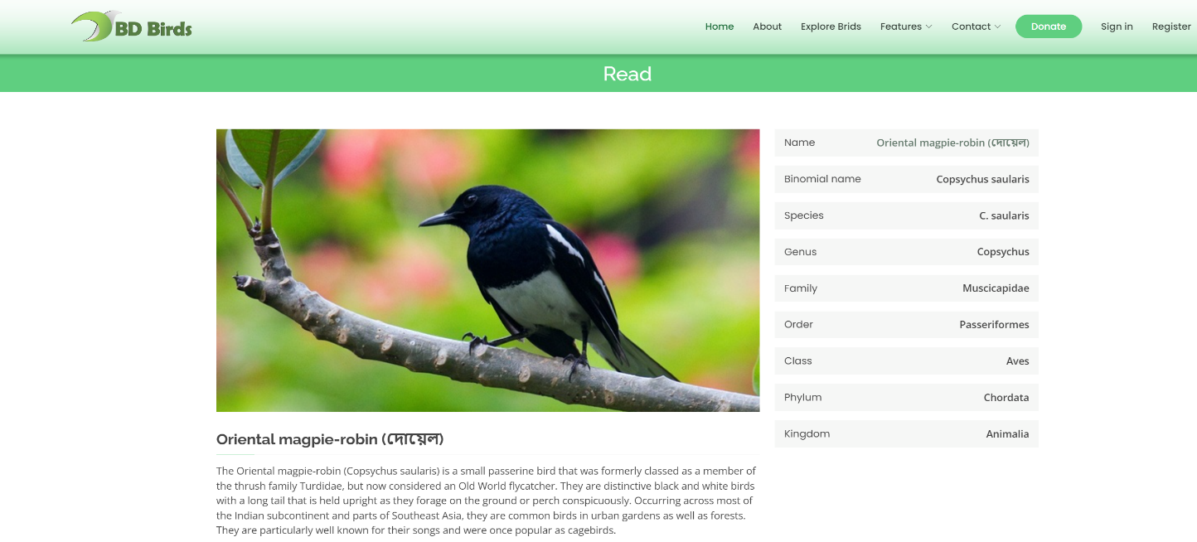

Fig 4.30: Articles

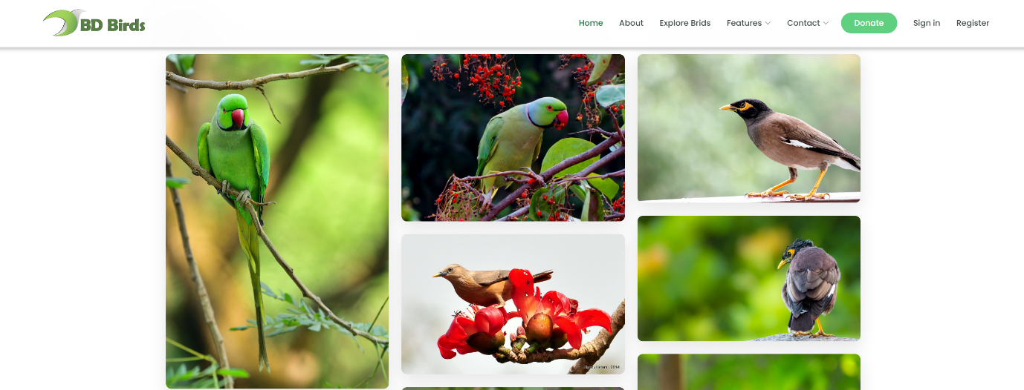**Birds Gallery Page**

Fig 4.31: Birds Gallery Page

The ‘Birds Gallery Page’ is a collection of high-resolution bird images, offering a simple and enjoyable viewing experience. User can navigate through various bird species effortlessly with the user-friendly slider.

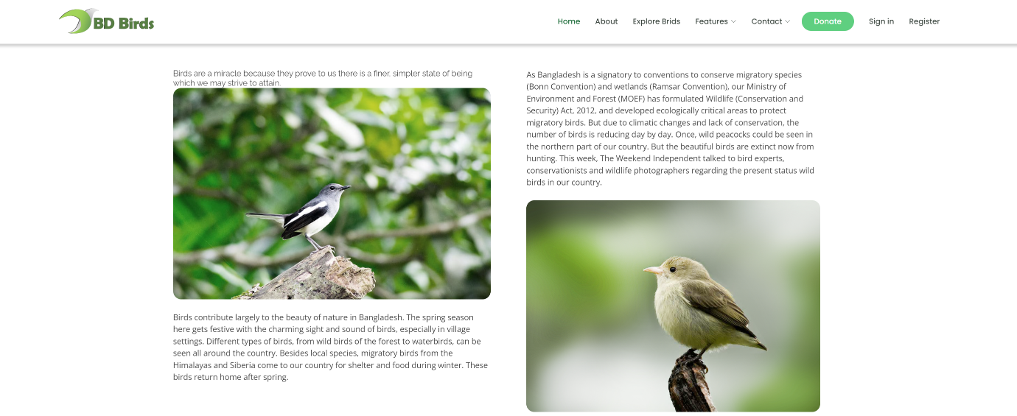**Explore Birds Page**

Fig 4.32: Explore Birds Page

**About Us page**

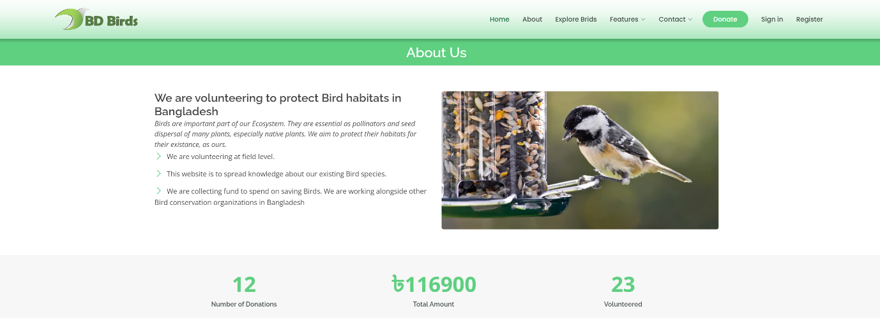

Fig 4.33: About Us Page

**4.2.10 Administration Page**

**Admin Login**

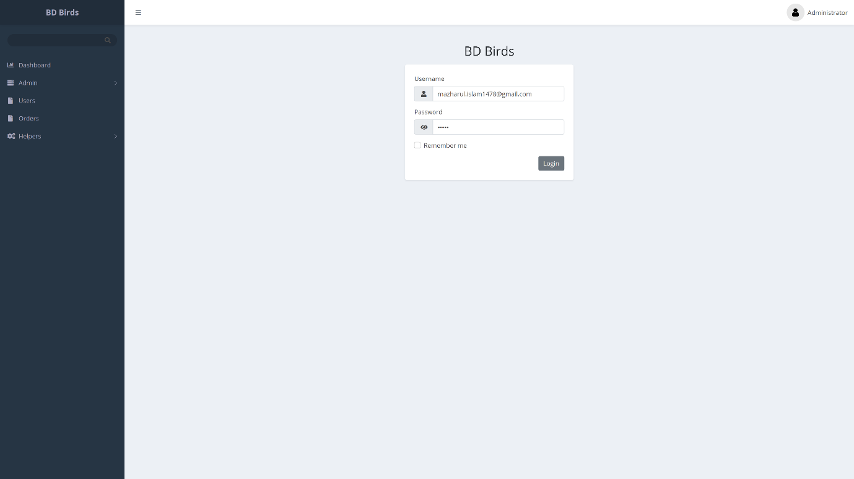

Fig 4.34: Admin Login Page

Admin will sign in to this Admin Login page and get access to specific administration features according to their roles. Administrators can implement brute-force protection mechanisms to limit the number of login attempts within a certain timeframe, reducing the risk of brute-force attacks. It has other Laravel built-in security system to protect the site against malicious attacks.

**Dashboard and Administrators**

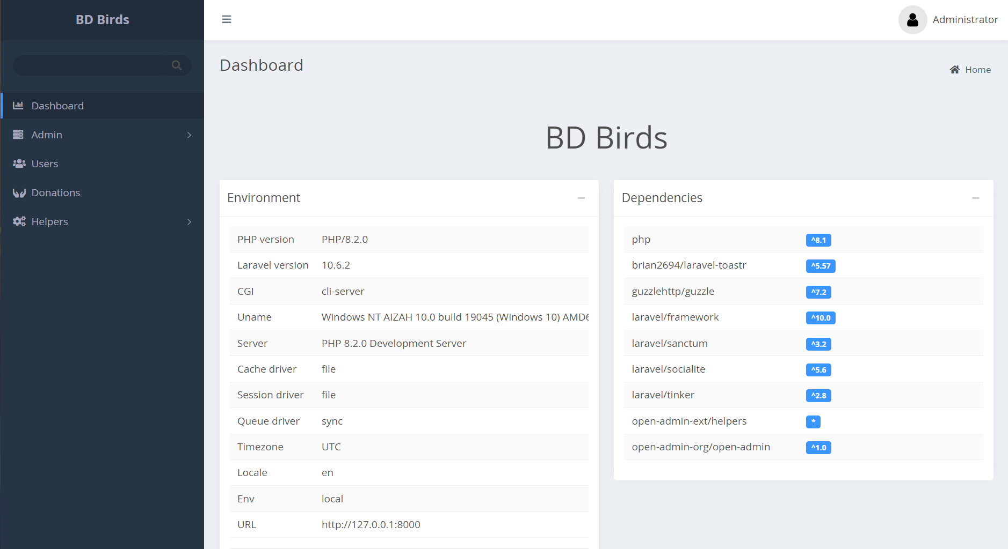

Fig 4.35: Admin Dashboard Page

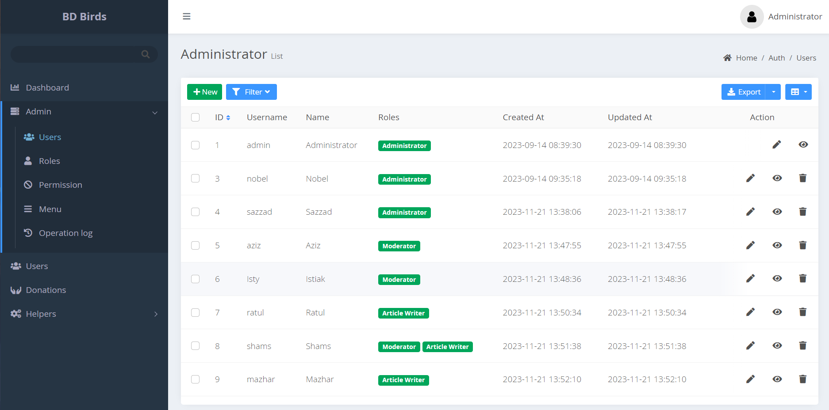

Fig 4.36: Admin Users Table

**Maintaining User and Donation**

Users Table and Donations Table from mysql database is imported in Administration Page for better maintenance.

Users table has essential fields such as id, name, email, and password. It stores passwords securely using techniques like bcrypt hashing. Additional Information: Include fields for any additional user information, such as contact details or membership status.

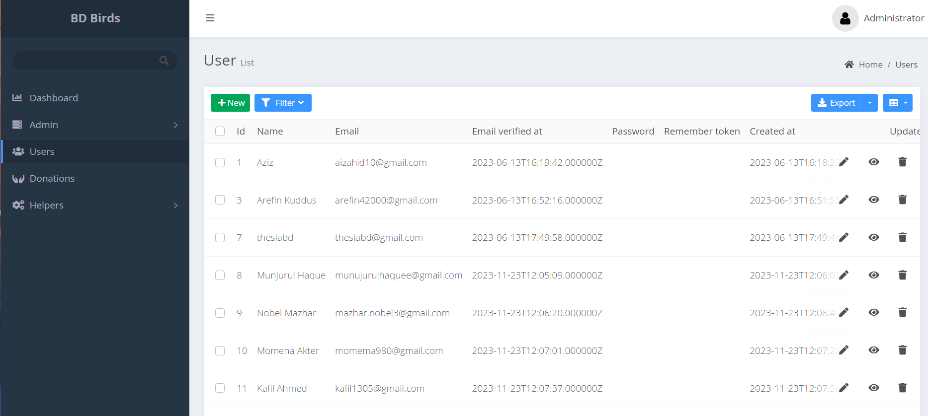

Fig 4.37: Registered Users Table

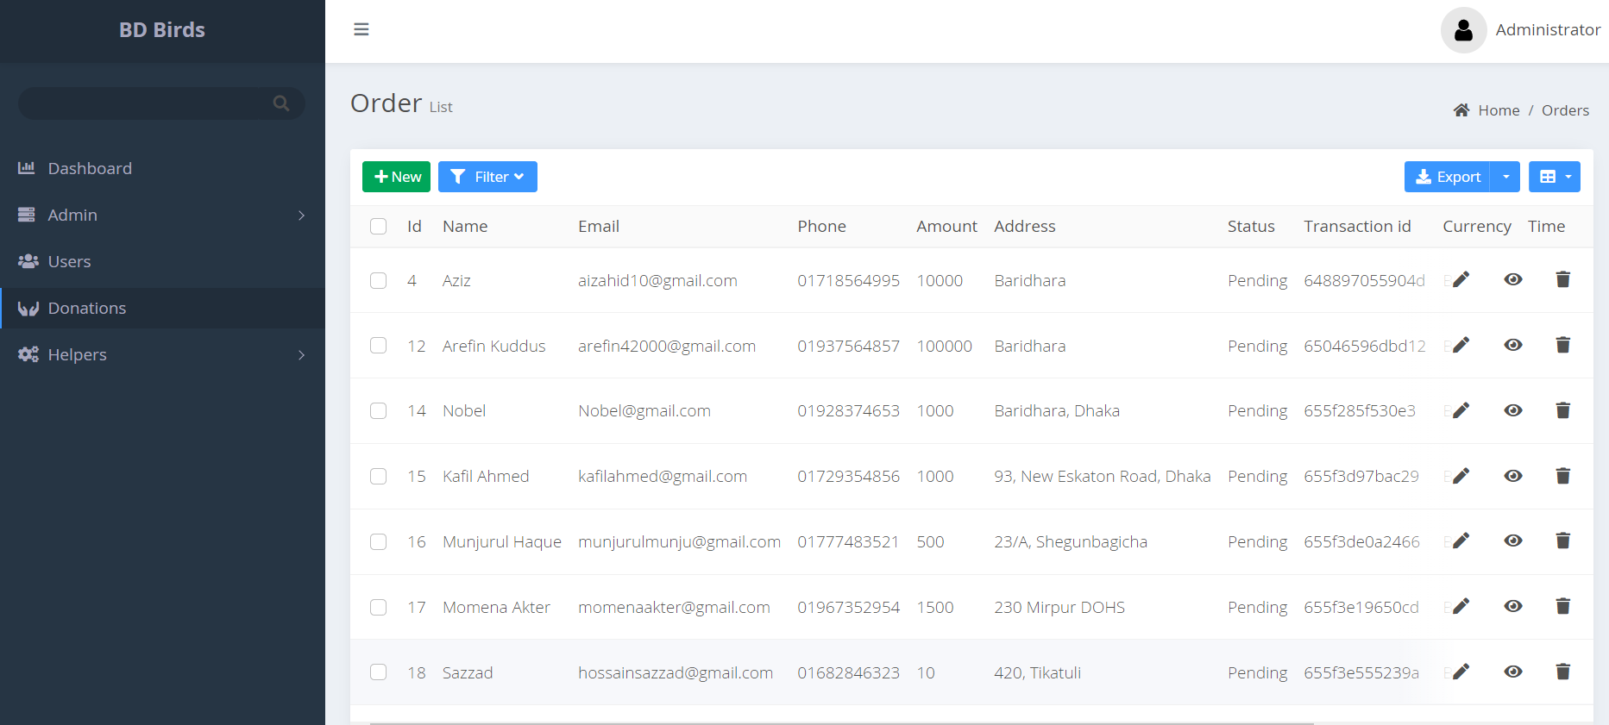

Fig 4.38: Donations table

**Operation Log**

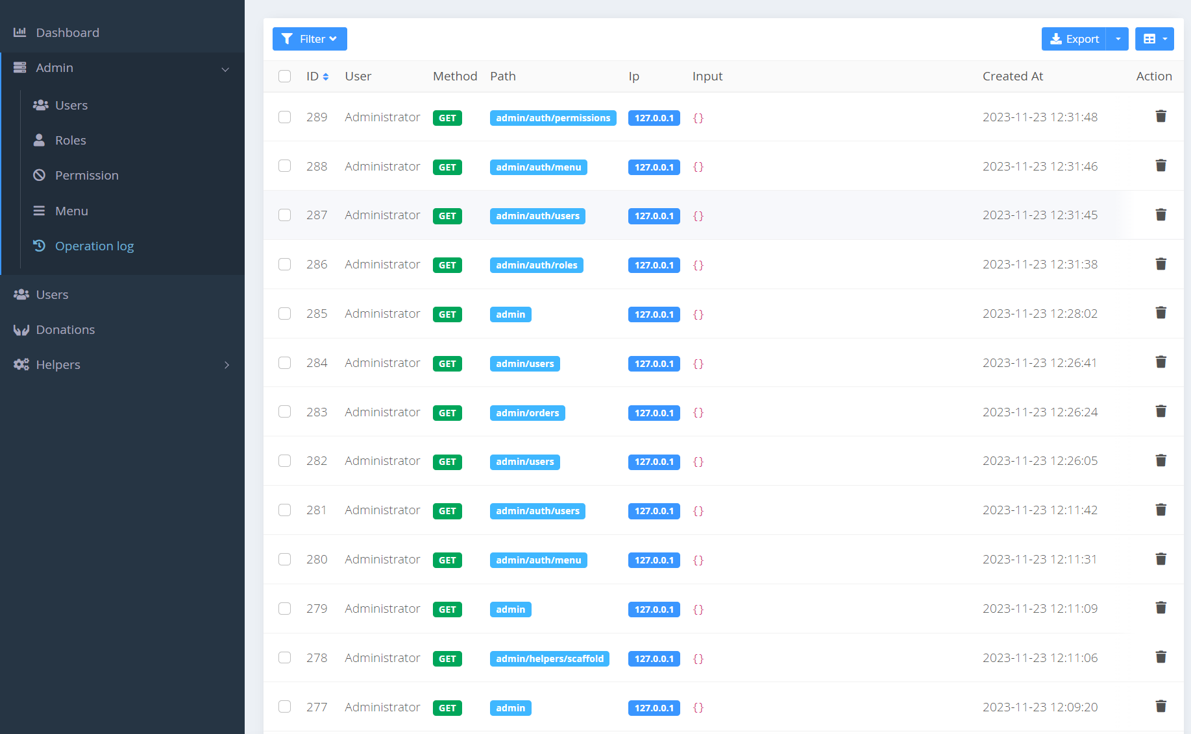Operation log give access to senior admins to see all the admin activity on the Administration Page.

Fig 4.39: Operation Log Table

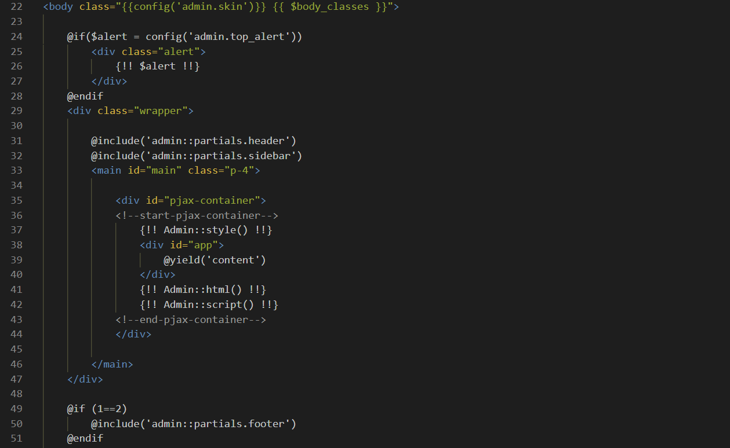

Fig 4.40: Code of Admin Blade Template

The code above sets up the admin page, its interface. It has its own layout function to add header and footer to the main content. The main content of admin panel includes total control of every admin and user information.

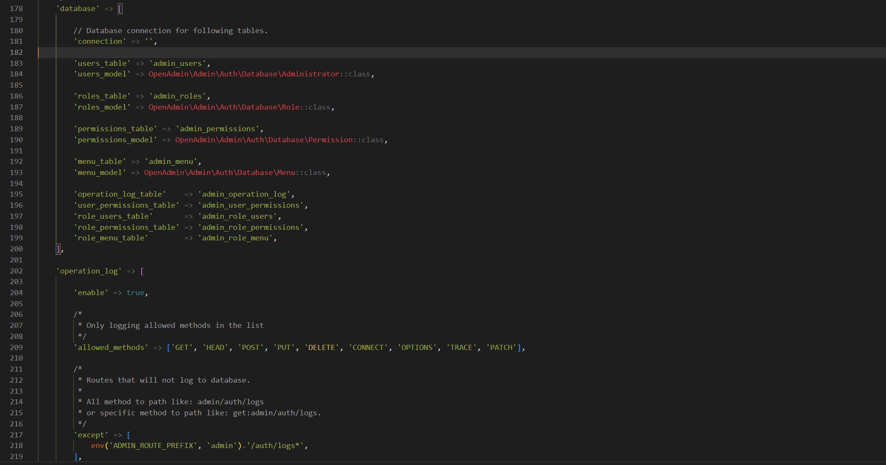

Fig 4.40: Code of admin.php

This particular code above from admin.php sets admin information to database and verify at every login attempt.

**4.3 MVC**

**Model**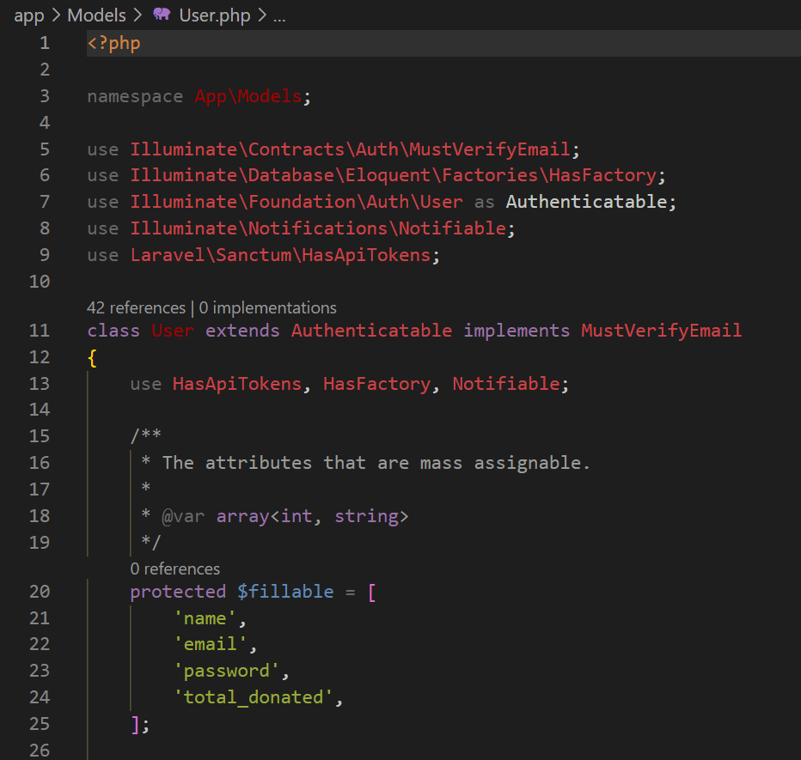

Fig 4.41: Code of User Model

This code defines a User model in a Laravel application.

* It extends Laravel's built-in Authenticatable class, providing authentication functionality.
* Implements the MustVerifyEmail contract, indicating support for email verification.
* Uses several traits (HasApiTokens, HasFactory, Notifiable) to enhance the model with API token support, factory methods, and notification capabilities.

**View**

We have shown the codes of View earlier. In fact, every page is a view or blade templeate and most of the codes shown earlier are from Views

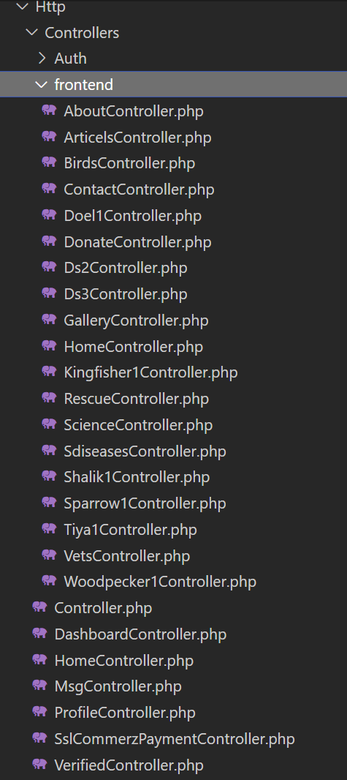**Controller**

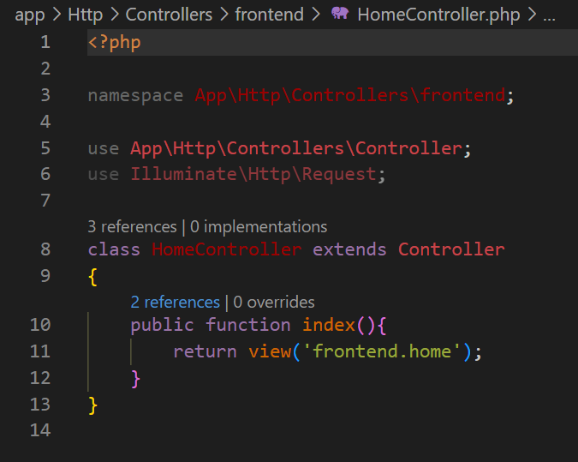

Fig 4.42: Code of Home Controller

Let's break down the key elements of this controller:

**Namespace:** The controller is placed within the App\Http\Controllers\frontend namespace. This helps organize controllers and avoid naming conflicts with other parts of the application.

**Controller Inheritance:** The controller extends the base Controller class provided by Laravel. This base class contains common methods and functionality that controllers can leverage.

**Method ‘index’:** In Laravel, this method typically corresponds to the default action when a user accesses a specific route associated with this controller.

**Request Dependency Injection:** The controller method accepts an instance of the Request class as a parameter. This allows the controller to access and handle any incoming HTTP request data if needed.

**Middleware**

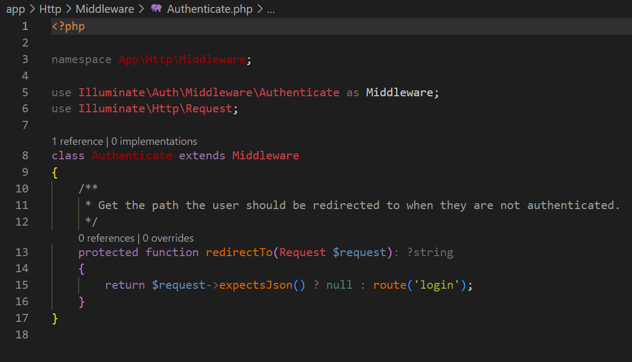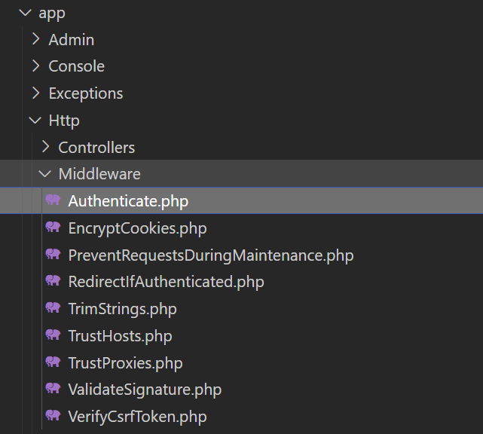

Fig 4.43: Code of User Authentication Middleware

This middleware is named Authenticate and is located within the App\Http\Middleware namespace. Let's break down its key components:

* The Authenticate middleware includes a method named ‘redirectTo’. This method determines the path to which a user should be redirected if they are not authenticated.
* If the request expects a JSON response (checked using $request->expectsJson()), indicating an API request, the method returns null. This means no redirection occurs for JSON requests.
* For non-JSON requests, it returns the route named 'login'. This implies that if a user is not authenticated and the request is not a JSON request, they will be redirected to the login page.

In summary, this middleware enhances the default Authenticate middleware behavior by customizing the redirection logic when a user is not authenticated.

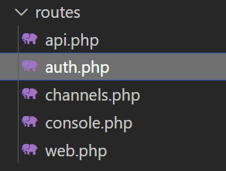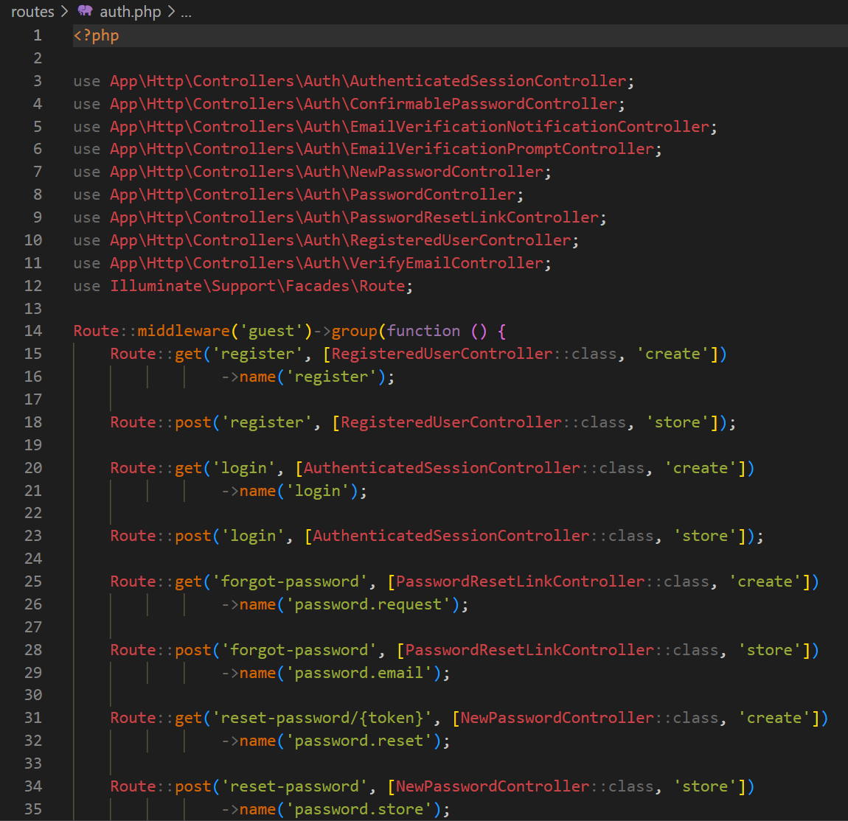**Routes**

Fig 4.44: Code of User Authentication Route

The code sets up routes for user authentication in the application.

**Middleware Group:** Routes are grouped under the 'guest' middleware, allowing access only to unauthenticated users.

**User Registration, Login Routes and Password Reset Routes:** ‘GET’ route to display the forms. ‘POST’ route to handle form submissions.

**Environment**

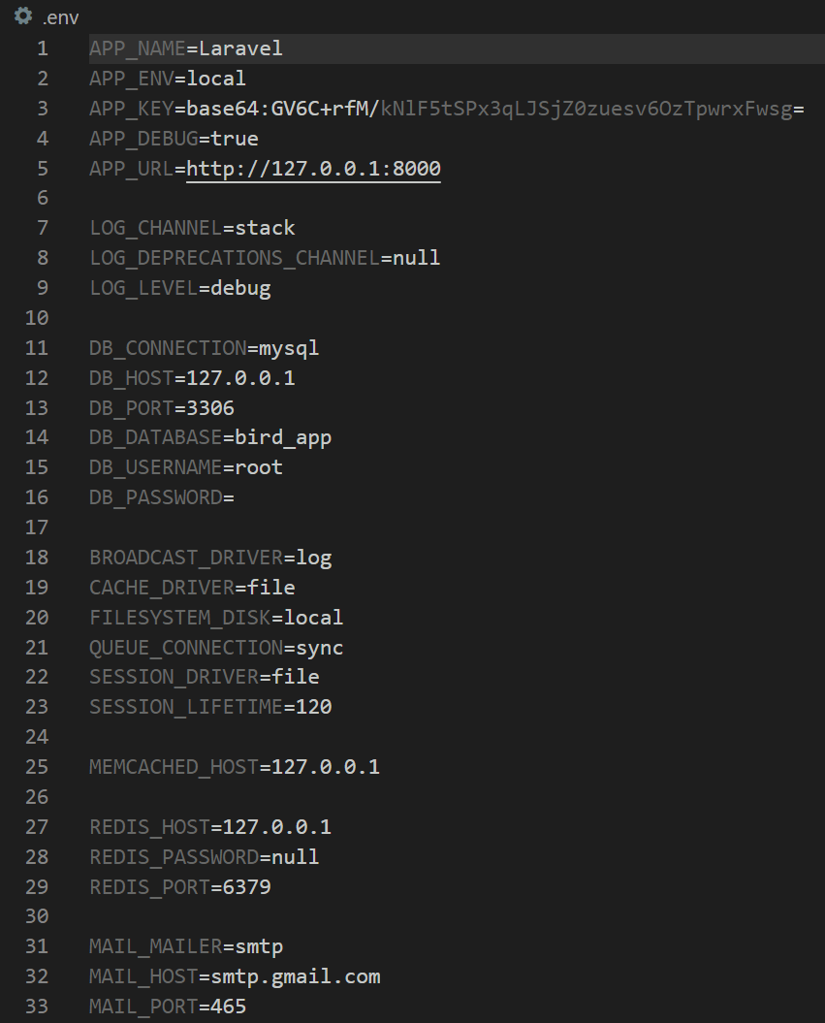

For example:

**Application Configuration:**

* APP_NAME: Specifies the name of the Laravel application.
* APP_ENV: Defines the environment (local, production, etc.) in which the application is running.
* APP_KEY: Represents the application key, used for encryption and security.

Fig 4.45: Code of Application Environments

The .env file in Laravel contains configuration settings for the application. Key configurations include the application name, environment, encryption key, debugging status, database connection details, logging preferences, cache, session, queue, mail, and settings for external services. This file helps customize the behavior of the Laravel application and separates sensitive information from the codebase.

**4.4 Database**

Tables are database objects that contain all the data in a database. In tables, data is logically organized in a row-and-column format similar to a spreadsheet. Each row represents a unique record, and each column represents a field in the record.

1. **Database all Table**

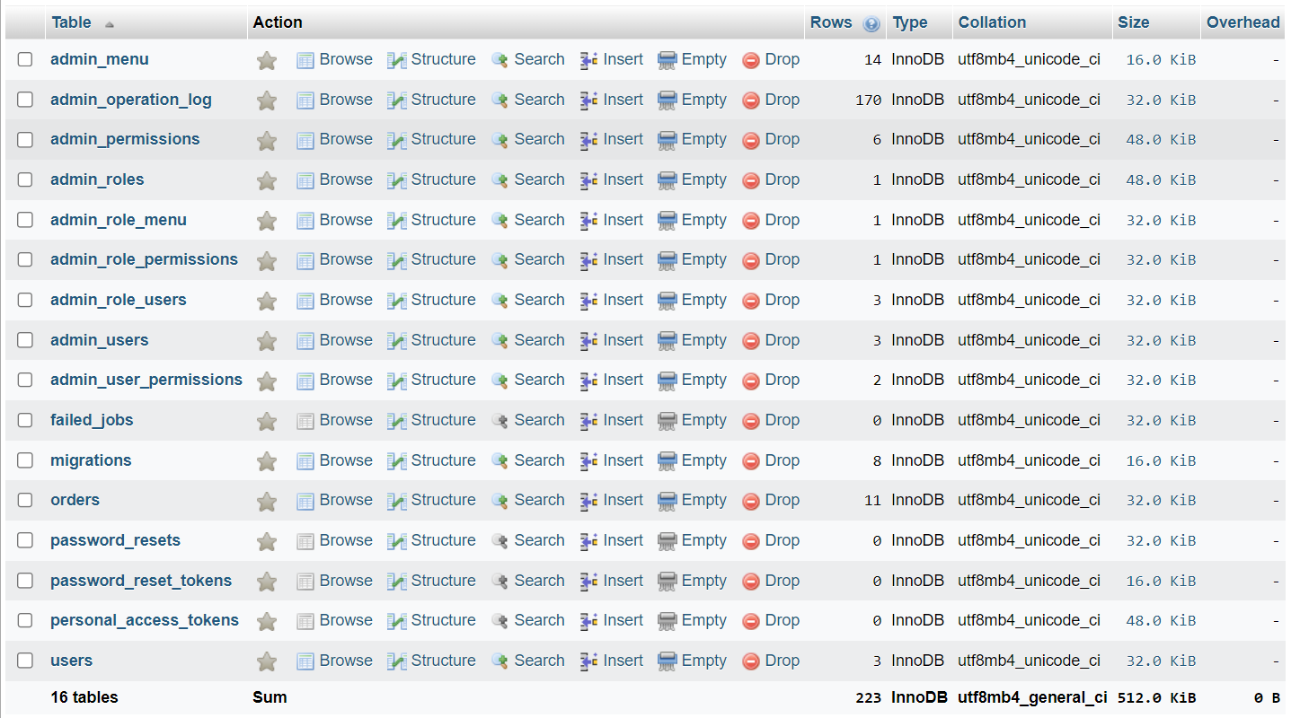

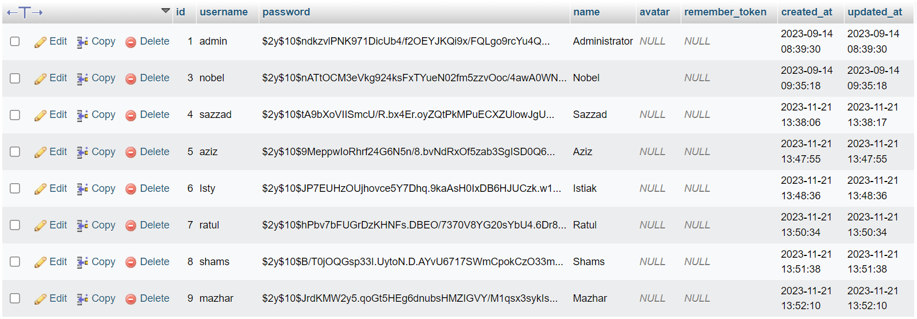

This table contains all the admins with different roles and permissions.

Fig 4.47: Admin Users Table

1. **Admin Users Table**

Fig 4.46: All Database Table

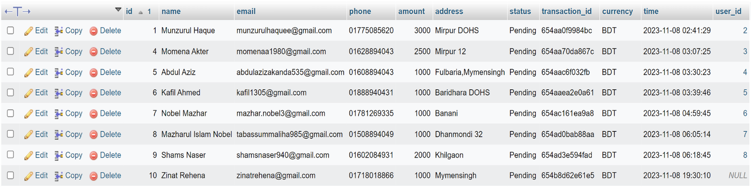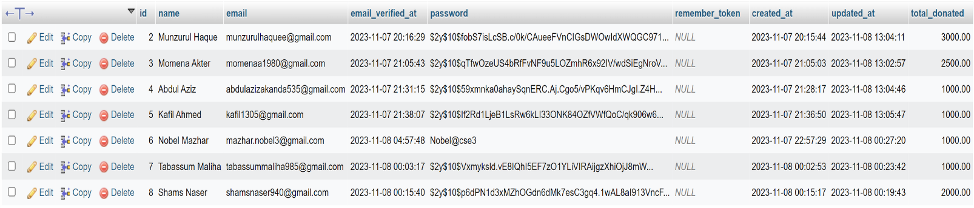

This table contains all the donations made by registered or non-registered user, their billing address, donation time and amount.

Fig 4.49: Donations Table

1. **Donations Table**

This table contains all registered users’ information including id, name, email, password, account creation time, total donated amount etc.

Fig 4.48: Registered Users Table

1. **Registered Users Table**

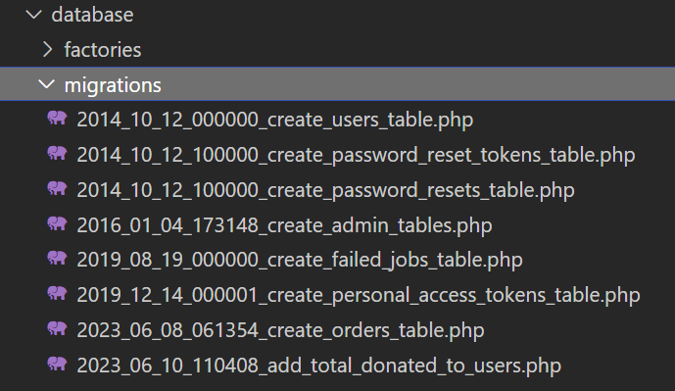**Database and Migration**

Migrations define the structure of the database, including tables, columns, indexes, and relationships. They provide a version-controlled and programmable way to create and modify the database schema. Migrations are a crucial part of the development workflow.

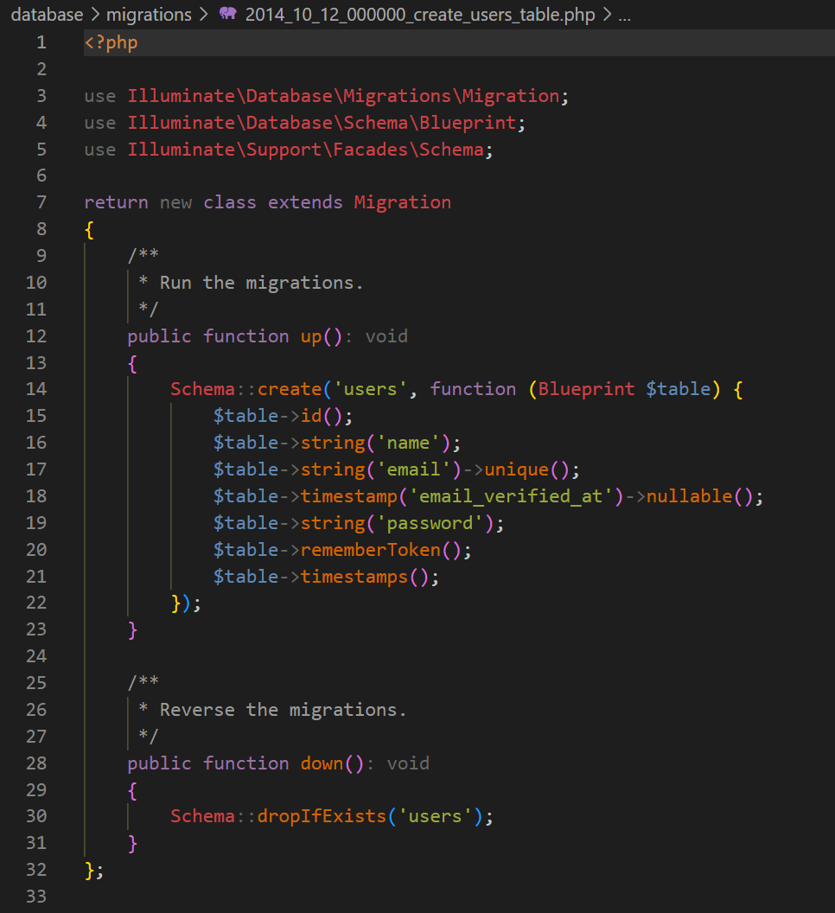

Fig 4.50: Table Migration Files

Fig 4.51: Code of Table Creation and Migration

A 'rememberToken' column is included for the "remember me" functionality. Lastly, two timestamp columns, 'created_at' and 'updated_at,' automatically record the user's creation and last update times.

In summary, this migration sets up the foundational structure for a user authentication system, defining the database schema for storing user information.

This migration sets up a 'users' table in the database with seven columns. The 'id' column serves as an auto-incrementing primary key, uniquely identifying each user. The 'name' column is designated for storing the user's name, while the 'email' column, marked as unique, holds the user's email address. The 'email_verified_at' column is a nullable timestamp, capturing when the user's email was verified, and the 'password' column stores the hashed user password.

**CHAPTER V**

**RESULT AND DISCUSSION**

The evaluation of the Online Bird Rescue Platform unravels a narrative of commendable achievements and areas of refinement in its quest to facilitate bird rescues, cultivate avian awareness, and engage a dynamic user community.

**Triumphs in Bird Rescues and User Engagement:** Undoubtedly, the platform has registered substantial success in orchestrating bird rescues, attributed in large part to the fervent involvement of its users. The evident uptick in successful bird rescues speaks volumes about the platform's effectiveness. However, beneath this success lies an opportunity for further refinement of user engagement strategies. Delving into the realm of gamification, acknowledging user contributions, and fostering a vibrant sense of community could propel the platform towards more extensive and enduring user participation.

**Educational Impact and Financial Support through Donations:** The platform's educational materials have made strides in enhancing avian awareness, garnering positive feedback. However, the quest for knowledge is a journey with no fixed destination; hence, there is a need to expand the content landscape to encompass a comprehensive array of avian topics. Simultaneously, the integration of a seamless donation mechanism emerges as a critical initiative to fortify financial support for ongoing bird rescue endeavors. Encouraging users to contribute monetarily through transparent donation channels not only aligns with the platform's mission but also ensures its enduring sustainability.

**User Interface Challenges and Continuous Improvement:** User feedback has sounded a clarion call on the importance of an intuitive and accessible platform design. Reports of users encountering challenges in navigating specific features underscore the imperative for continuous improvements. Prioritizing user-centric design updates, executing periodic usability assessments, and incorporating responsive user feedback mechanisms emerge as essential strategies for enhancing the overall user experience.

**CHAPTER VI**

**CONCLUSION AND FUTURE WORK**

**6.1 Conclusion**

The culmination of the Online Bird Rescue Platform's current endeavors paints a portrait of both accomplishment and aspiration. As we reflect on the achievements in facilitating successful bird rescues, fostering avian awareness, and cultivating a vibrant user community, it becomes apparent that the platform has become a valuable nexus for avian enthusiasts and advocates. However, this juncture is not a terminus but a waypoint in a trajectory of continuous improvement.

**Achievements and Acknowledgments:** Acknowledging the success in orchestrating bird rescues, with a significant uptick in positive outcomes, is a testament to the platform's efficacy. The dynamic engagement of users, their passionate involvement, and the positive impact on avian awareness affirm the platform's role as a catalyst for positive change.

**Areas for Refinement and Continuous Evolution:** Yet, as with any pioneering venture, there are avenues for refinement. User engagement strategies, while successful, warrant ongoing enhancement to ensure sustained and widespread involvement. Educational content, although impactful, presents an opportunity for expansion, diversification, and a commitment to covering a comprehensive spectrum of avian topics.

**Financial Sustainability and Donor Engagement:** The integration of a seamless donation mechanism represents a pivotal step towards ensuring financial sustainability. Encouraging users to contribute monetarily through transparent channels is not merely a financial strategy but a manifestation of a community united by a shared cause.

**Usability and Design Excellence:** User feedback highlighting interface challenges serves as a call to action for continuous improvement. Prioritizing user-centric design updates, regular usability assessments, and an unwavering commitment to responsive design will fortify the platform's position as an accessible and user-friendly hub.

**6.2 Future Work**

The road ahead beckons with possibilities and potential avenues for the Online Bird Rescue Platform to evolve and amplify its impact:

**User Engagement Strategies:** Delve deeper into gamification, community-building initiatives, and acknowledgment mechanisms to fortify user engagement and cultivate a more enduring and dynamic community.

**Educational Expansion:** Embark on a journey of enriching and diversifying educational content, ensuring it remains a beacon for avian enthusiasts seeking knowledge and awareness.

**Donation Mechanism Optimization:** Continuously refine and optimize the donation mechanism, exploring innovative approaches to encourage financial support for sustained bird rescue initiatives.

**User Interface Enhancement:** Implement a phased approach to user interface enhancements, integrating design updates that prioritize user-centricity and accessibility.

**Collaborative Initiatives:** Forge partnerships and collaborations with conservation organizations, educational institutions, and bird enthusiasts to amplify the platform's reach and impact.

**REFERENCES**

1. “Bird.” Banglapedia. [https://en.banglapedia.org/index.php/Bird](https://en.banglapedia.org/index.php/Bird%20). Accessed March 1, 2023.
2. “The IUCN Red List of Threatened Species.” <https://www.iucnredlist.org/>. Accessed March 19, 2023.
3. “List of birds of Bangladesh.” <https://en.wikipedia.org/wiki/List_of_birds_of_Bangladesh>. Accessed March 1, 2023.
4. “Wildlife-Sanctuary.” <https://bforest.gov.bd/site/page/f619019f-14cd-481a-86f4-1d5b4ae40515/Wildlife-Sanctuary/>. Accessed March 4, 2023.
5. “DIGITAL 2023: BANGLADESH.” Data Portal. <https://datareportal.com/reports/digital-2023-bangladesh>. Accessed March 2, 2023.
6. “Volunteering Statistics for 2023: How Charitable Are We?” <https://teamstage.io/volunteering-statistics/>. Accessed March 23, 2023.
7. Bjorklund, Ruth, “Wildlife Rescue and Rehabilitation Worker: First Editioin.” pp. 13. Publisher: New York Cavendish Square, 2014.
8. “Obstacles Rescue Volunteers Face and How You Can Help.” <https://whiskerstotailspetsitting.com/2022/03/obstacles-rescue-volunteers-face-and-how-you-can-help/>. Accessed March 21, 2023.
9. “How to Create a Standout Animal Rescue Website.” <https://roedigital.com/animal-rescue-website/>. Accessed April 30, 2023.
10. Tomer Simon, Bruria Adini, Mohammed El-Hadid, Avishay Goldberg, Limor Aharonson-Daniel, “The race to save lives: demonstrating the use of social media for search and rescue operations.” <https://pubmed.ncbi.nlm.nih.gov/25685618/>. 2014.
11. “Research and Innovation.” <https://www.birdrescue.org/our-work/research-and-innovation/>. Accessed March 16, 2023.
12. Madelene Blaer, “Animal rescue tourism: digital technology-enhanced approaches to support voluntourist engagement, animal welfare and rights.” <https://www.tandfonline.com/doi/abs/10.1080/02508281.2022.2046991>. Accessed February 7, 2023.
13. Sutirtho Roy, “Role Of Social Media In Conservation.” <https://wildlifesos.org/chronological-news/role-of-social-media-in-conservation/>. 2023.
14. Edward N. Eadie, “Education for Animal Welfare: First Edition.” pp. 37-68. 2011.
16. Renee Garett, [Jason Chiu](https://pubmed.ncbi.nlm.nih.gov/?term=Chiu%20J%5BAuthor%5D), [Ly Zhang](https://pubmed.ncbi.nlm.nih.gov/?term=Zhang%20L%5BAuthor%5D), [Sean D. Young](https://pubmed.ncbi.nlm.nih.gov/?term=Young%20SD%5BAuthor%5D), “Website Design and User Engagement.” [https://www.ncbi.nlm.nih.gov/pmc/articles/PMC4974011/.](https://www.ncbi.nlm.nih.gov/pmc/articles/PMC4974011/.%20) 2016.
17. “Software Development Methodologies: Everything You Need to Know.” [https://www.simplilearn.com/software-development-methodologies](https://www.simplilearn.com/software-development-methodologies-article%23:~:text=Software%20engineering%20methodologies%20are%20important,you%20in%20the%20technology%20field.). Accessed April 3, 2023.
18. “Laravel.” Retrieved from <https://github.com/laravel/laravel>. Accessed April 9, 2023.
19. “Bringing MySQL to the web.” <https://www.phpmyadmin.net/>. Accessed April 29, 2023.
20. “HTML5.” <https://www.w3.org/TR/2008/WD-html5-20080122/>. Accessed April 1, 2023.
21. “HTML5 is a W3C Recommendation” <https://www.w3.org/news/2014/html5-is-a-w3c-recommendation/>. Accessed April 1, 2023.
22. “CSS Introduction.” <https://www.w3schools.com/css/css_intro.asp>. Accessed April 2, 2023.
23. “PHP Tutorial.” <https://www.w3schools.com/php>. Accessed April 3, 2023.
24. **“Introduction to JavaScript.**” <https://javascript.info/intro>. Accessed April 22, 2023.
25. McCoy R., “The right way to read files with PHP.” <https://developer.ibm.com/articles/os-php-readfiles/>. 2007.
26. **“Bootstrap Overview**.” <https://getbootstrap.com/docs/5.1/about/overview/>. Accessed April, 2023.
27. **“The PHP Framework for Web Artisans.”** <https://laravel.com/>. Accessed April 24, 2023.
28. “Laravel.” <https://en.wikipedia.org/wiki/Laravel>. Accessed April 1, 2023.
29. “Understanding MVC Architecture with Example.” <https://www.tutorialspoint.com/mvc_framework/mvc_framework_introduction.htm>. Accessed May 2, 2023.
30. “MVC Framework Introduction.” <https://www.geeksforgeeks.org/mvc-framework-introduction/>. Accessed April 9, 2023.
31. Welling L., Thomson L. “Building a PHP-MySQL Web Page. PHP and MySQL Web Development: Sixth Edition”, pp. 2. 2021.

**Appendix - Complex Engineering**

**Complex Engineering Problem (Ps):**

|  |  |  |  |  |
| --- | --- | --- | --- | --- |
| **Ps** | **Attribute** | **How Ps are addressed through the project** | **CO** | **PO** |
| **P1** | Depth of Knowledge Requirement | The development of the Online Bird Rescue Platform demanded a strong foundation in engineering fundamentals (K3) for crafting the Laravel framework, emphasizing design considerations (K5) and efficient resource allocation through intricate coding (K6). In addition, extensive insights from research literature (K8) were incorporated to enhance the platform's functionality, ensuring a well-informed and robust development process. | **CO1**  **CO2** | **PO a**  **PO b**  **PO c** |
| **P2** | Range of Conflicting Requirement | Effectively managing the conflicting demands of ensuring a prompt response to rescue requests while optimizing server resource utilization is a pivotal challenge. Striking a balance between responsiveness and resource efficiency demands a meticulous approach and the implementation of innovative solutions. | **CO1** | **PO a** |
| **P3** | Depth of Analysis Required | Addressing issues related to database integration, ensuring seamless communication between different modules, and optimizing the platform's performance were paramount. In-depth analysis was indispensable to identify and resolve coding intricacies, debug software components, and ensure the robustness of the overall system. | **CO2**  **CO3**  **CO4** | **PO b**  **PO c**  **PO d**  **PO g** |
| **P7** | Interdependence | The engineering intricacies within the bird rescue platform manifest in the coordination of subsystems devoted to data management, user engagement, and educational content delivery. Achieving a seamless integration of these components is vital for the platform's effectiveness. | **CO3**  **CO5**  **CO6** | **PO i**  **PO k**  **PO j** |

|  |  |
| --- | --- |
| **Knowledge Profile (K)** | **Short Name** |
| K1 | Natural Sciences |
| K2 | Mathematics |
| K3 | Engineering Fundamentals |
| K4 | Specialist Knowledge |
| K5 | Engineering Design |
| K6 | Engineering Practice |
| K7 | Comprehension |
| K8 | Research Literature |

|  |  |  |
| --- | --- | --- |
| **As** | **Attribute** | **How As are addressed through the project** |
| **A1** | Range of resources | This project needed the use of diverse resources including volunteers, money and leveraging technologies that enhance the user experience, such as educational modules and a streamlined bird rescue queue. |
| **A2** | Level of interaction | We addressed critical challenges by implementing features like profile registration, donation options, and a comprehensive rescue system. These solutions resolve issues related to user engagement, funding for bird rescue operations, and efficient management of rescue efforts. |
| **A4** | Consequence for society and the environment | This platform is created by recognizing the environmental consequences of bird endangerment. By raising awareness through the education hub, the platform contributes positively to society by encouraging environmental responsibility and fostering a sense of urgency for bird conservation. |
| **A5** | Familiarity | The familiarity lies in the principles-based approach of making these processes intuitive, thereby encouraging wider participation from users who may not have extensive technical expertise. |